**Predictive analysis of city based crops using Internet of Things based Hydroponic system**

A PROJECT REPORT

submitted by

**S A HARIPRASAD (18BCE0686)**

**NIKHIL K (18BCE2321)**

*in partial fulfilment for the award* of the degree of

**B. Tech**

in

**Computer Science and Engineering**



       Vellore-632014, Tamil Nadu, India

**School of Computer Science and Engineering**

May, 2022

(i)



**School of Computer Science and Engineering**

**DECLARATION**

I hereby declare that the project entitled **“Predictive analysis of ambient conditions for crop growth using Internet of Things”** submitted by me to the School of Computer Science and Engineering, Vellore Institute of Technology, Vellore-14 towards the partial fulfilment of the requirements for the award of the degree of **Bachelor of Technology in Computer Science and Engineering** is a record of bonafide work carried out by me under the supervision of **Yokesh Babu S, Assistant Professor(Selection Grade).** I further declare that the work reported in this project has not been submitted and will not be submitted, either in part or in full, for the award of any other degree or diploma of this institute or of any other institute or university.

Signature

Name :S A Hariprasad

Reg.No:18BCE0686



**School of Computer Science and Engineering**

**CERTIFICATE**

The project report entitled “**Predictive analysis of ambient conditions for crop growth using Internet of Things**” is prepared and submitted by **Candidate’s S A Hariprasad(18BCE0686),Nikhil K(18BCE2321) ,** has been found satisfactory in terms of scope, quality and presentation as partial fulfillment of the requirements for the award of the degree of **Bachelor of Technology in Computer Science and Engineering** in Vellore Institute of Technology, Vellore-14, India.

**Guide**

**(Name & Signature)**

**Internal Examiner External Examiner (Name & Signature) (Name & Signature)**

**ACKNOWLEDGEMENT**

I am indebted to many people who helped me accomplish this project successfully.

Firstly, I express my gratitude to VIT University, Vellore and the HOD and Dean, Scope to make me eligible to seek this opportunity. I perceive this opportunity as a milestone for my learning in the university.

I would like to express a deep sense of gratitude to Dr. Yokesh Babu S, for my entire duration of project without whose wise counsel and able guidance, it would have not been possible to carry out the project in this manner.

I would like to express my gratitude to my friend and my project mate Nikhil K , for collaborating and helping me to carry out the project

I express my indebtedness to all who have directly and indirectly contributed to the successful completion of my project.

Finally , I thank my parents for their blessing and constant support, without which this project would not have seen the light of the day.

**S A HARIPRASAD**

**TABLE OF CONTENTS**

**Title Page**

Title Page i

Declaration ii

Certificate iii

Acknowledgement iv

Table of Contents v

List of Tables vi

List of Figures vii

List of Abbreviations viii

Abstract ix

1. Introduction 11
   1. Theoretical Background
   2. Motivation
   3. Aim of the proposed work
   4. Objectives of the proposed work
   5. Report Organization
2. Literature Survey 13
   1. Survey of the Existing Models and Works
   2. Summary and Gaps identified in survey
3. Technical specification 21
   1. Introduction
   2. Proposed System
   3. Proposed System Model
4. Design Approach And Details 24
   1. Introduction
   2. Requirement Analysis
      1. Functional Requirements
         1. Product Perspective
         2. Product Features
         3. User Characteristics
         4. Assumption and Dependencies

(iv)

* + - 1. Domain Requirements
      2. User Requirements
    1. Non-Functional Requirements
       1. Product Requirements
          1. Efficiency
          2. Reliability
          3. Portability
    2. System Requirements
       1. Hardware Requirements
       2. Software Requirements

1. Schedule Tasks and Milestones 28
   1. Gantt Chart
   2. Timeline of Work
2. Results and Discussion 30
   1. Sample Test Cases
   2. Summary of Results
3. Conclusion 59
   1. Limitations
   2. Scope for future work

Annexure – I (Sample codes) 60

References 69

**LIST OF TABLES**

Table 1: Tabular literature Survey 20

Table 2:Pin Diagram for Circuit 24

Table 3:Range of parameters Phase-1 28

Table 4:Dataset Description Phase-1 28

Table 5:Range of parameters Phase-2 29

Table 6:Dataset Description Phase-2 29

Table 7:Range of parameters phase-3 30

Table 8:Dataset description Phase-3 30

Table 9:Range of parameters full data 30

Table 10:Range of Parameters full data 31

Table 11:Linear variation of parameters with respect to time 36

Table 12:Linear variation of Ph with other parameters 37

Table 13:Linear Variation of water level with other parameters 38

Table 14:Linear variation of sunlight with other parameters 39

Table 15:Linear variation of temperature with other parameters 40

Table 16:Linear variation of humidity with other parameters 41

Table 17:Linear variation of soilmoisture with other parameters 42

Table 18:Linear Regression Between Parameters for Initial Phase of Coriander Plant Growth 43

Table 19:Linear Regression Between Parameters for Growing Phase of Coriander Plant Growth 44

Table 20:Linear Regression Between Parameters for Harvesting Phase of Coriander Plant Growth 46

Table 21: Linear Regression Between Parameters for Full Phase of Coriander Plant Growth 46

Table 22:Linear Regression Between Parameters for Full Phase of Coriander Plant Growth 47

Table 23:Support Vector Regression Between Parameters for Initial Phase of Coriander Plant Growth 49

Table 24:Support Vector Regression Between Parameters for Growing Phase of Coriander Plant Growth 50

Table 25:Support Vector Regression Between Parameters for Harvesting Phase of Coriander Plant Growth 51

Table 26:Support Vector Regression Between Parameters for Full Phase of Coriander Plant Growth 52

Table 27:Decision Tree Regression Between Parameters for Initial Phase of Coriander Plant Growth 54

Table 28:Decision Tree Regression Between Parameters for Growing Phase of Coriander Plant Growth 55

Table 29:Decision Tree Regression Between Parameters for Harvesting Phase of Coriander Plant Growth 56

Table 30:Decision Tree Regression Between Parameters for Full Phase of Coriander Plant Growth 58

Table 31:Yield generated through our hydroponic system 59

**LIST OF FIGURES**

Figure 1:Food requirements In India Across States 11

Figure 2:Population Density of Indian Cities 12

Figure 3:World Index Hunger across Indian States 12

Figure 4:Per Capita Food Grain Availability 12

Figure 5:Architecture Diagram 22

Figure 6:Circuit Diagram of System 23

Figure 7: Gantt chart for project 28

Figure 8: Time Line for project 28

Figure 9:Image of automated hydroponic system 61

Figure 10: Graphical user interface for hydroponic system 62

Figure 11: Hydroponic system code part-1 63

Figure 12:Hydroponic system code part 2 64

Figure 13:Code for data analysis 65

Figure 14:Code for linear regression analysis 66

Figure 15:Code for decision tree regression 68

**LIST OF ABBREVIATIONS**

**Abbreviation Expansion**

IOT Internet of Things

PH Presence of Hydrogen

LPWAN Low-Power Wide-Area Network

MAE Mean Absolute Error

MSE Mean Squared Error

RMSE Root Mean Squared Error

RMSLE Root Mean Squared Log error

R2 R Squared Error

**ABSTRACT**

In a rapidly developing country like India, which has the world’s highest growing GDP Urbanization is being seen in every nuke and corner of the country. The difference between the population density of the cities and rural areas are very high. The population of the cities are growing exponentially every year, because of which the agricultural farms in and around the cities are being converted into residential sky scrapers. The need and demand for crops and food is growing up but the area to grow is going down. Due to this alarming scenario, hydropic agriculture has risen in popularity and practice. It is a form of agriculture in which the plants are grown with restricted water supply. In this work, we are growing coriander plant in a controlled environment with constant monitoring, the controlled environment being restricted water supply I,e Hydroponic farming. Various parameters like Soil pH, Moisture levels etc. are recorded on daily basis and made into a data set. This data set, then  with the help of Supervised Machine Learning algorithms we are going to Co-Relate the data collected via IOT by the help of Regression Models ,find the trends within the taken parameters and give an idea as to which conditions give a better yield. The main objective of our work is to find and show the correlation between various parameters take into account while growing a crop through hydroponic agriculture and predict the range of parameters which result in the best growth of the crops.

*Keywords*: Supervised Machine Learning Algorithms, Regression Models, Controlled Environment, Hydroponic, Urbanization

# 1) Introduction

**1.1) Theoretical Background**

Agriculture is the primary occupation in India and is the backbone of Indian economic system. Agriculture provides employment opportunities to rural people on a large scale in underdeveloped and developing countries in addition to providing food. It is the process of producing food, fibre and many other desired products by the cultivation and raising of domestic animals. Agriculture is the primary source of livelihood for about more than 58% of India’s population.

**1.2) Motivation**

As the population of the city grows significantly the need to feed the city heavily lays on the need of agricultural land. As most of the agriculture lands are dried up due to lack of water the need for starvation increases. Hence cities have to start cultivating crops and the need for automated farming in cities becomes crucial.

Climate changes will have a significant impact on agriculture by increasing water demand and limiting crop productivity in areas where irrigation is most needed. Irrigation system, rain fed agriculture, groundwater irrigation are some of the methods introduced to produce healthier crops which may not use water efficiently. In order to use water efficiently a smart system is designed. In the system farmers need not make the water flow into fields manually, but the system automatically does that efficiently.

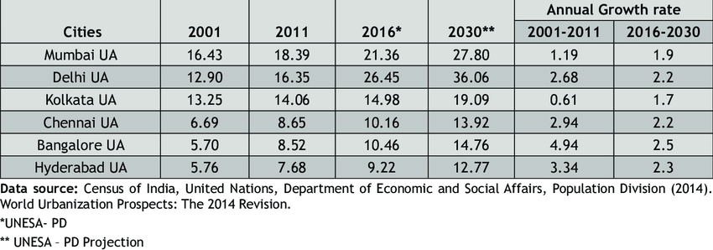

Figure 1:Food requirements In India Across States

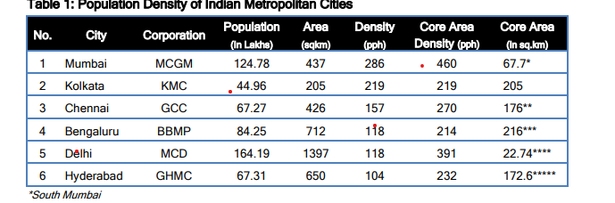

Figure 2:Population Density of Indian Cities

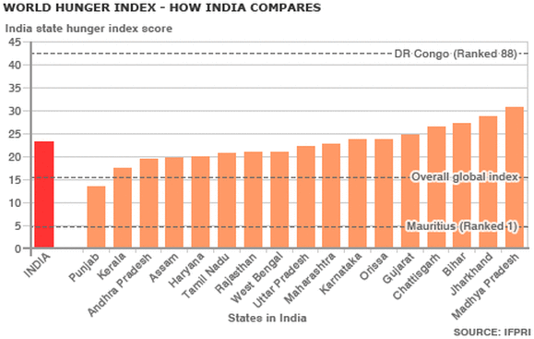

Figure 3:World Index Hunger across Indian States

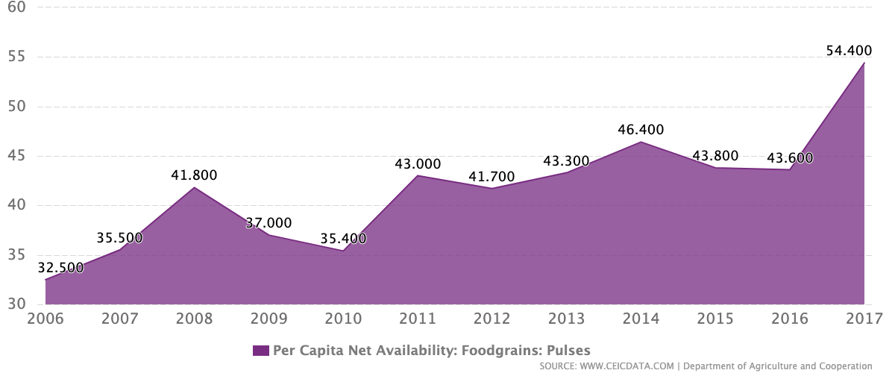

Figure 4:Per Capita Food Grain Availability

**1.3) Aim of the proposed Work**

The traditional methods practiced by people may result in huge wastage of water. Hence, the concept of robotized farming with a mix of IoT has been developed. The technological advancements began to increase the efficiency of production remarkably thus, making it a reliable system. The knowledge of properties of soil determines the water supply to be driven in a smart way. The practice of agriculture in a smart way helps to acquire knowledge of soil and temperature conditions. Developing the smart agriculture using IoT based systems not only increases the production but also avoids wastage of water

**1.4) Objective of the proposed work**

The main objective of our work is to find and show the correlation between various parameters take into account while growing a crop through hydroponic agriculture and predict the range of parameters which result in the best growth of the crops.

**1.5) Report Organization**

In our project we have implemented a hydroponic system to cultivate coriander crop where we are collecting data parameters such as ph value, temperature, humidity, soil moisture, and water level in the system. We are planning to collect data till the plant reaches its full growth and we will be analyzing the trends in data using regression model and data analysis. After analyzing the data, we will be able to implement a prototype that can help people grow crops in cities through automation and improve more cultivation in urban areas. Hydroponic systems are going to become the future of agriculture in urban areas and help farmers to reduce the burden to provide food to urban regions.

# 2) Literature Survey

**2.1) Survey of the Existing Models and Works**

|  |  |  |  |  |
| --- | --- | --- | --- | --- |
| S.No | Title | Authors | Methodologies Used | Drawbacks and Future Works |
| 1 | Data Acquisition and Actuation for Aquaponics using  IoT | Akhil Nicani, Sayantan Saha, Tushar Upadhyay, A. Ramya,  Maulin Tolia | Multi-Level IOT framework, which uses Application Layer, Internet Layer, Sensor and Actuator Framework along with Distribution middleware and follows MQTT protocol.  In the output, the End User Experiences VPS interaction in one aspect and in the other aspect, it uses VPS and Local Server Interaction | This works falls back in implementing limiting factors such as nitrate, nitrate and ammonia via the electronic sensors.  Automated data collection can be implemented into this work so that the system can function with better efficiency and maybe it could send alerts to the sender if there is any change or drastic changes in the parameters. |
| 2 | An eye on hydroponics: The IoT initiative | Joshitha C,  P Kanakaraja,  Sarath Kumar,  Polavarapu Akanksha,  Guduru Satish | The paper focuses on five main concepts, namely  Hydroponics, Need for Automation Control, Climate Statistics, Data Analytics and Cloud, Proposed System.  The sensors record analog Data through Hydroponic system with the help of MCP 3008 ADC. | This work acts as an eye mainly to farmers but this technology can sometimes act more of an ban than a boon for the farmers.  This work is done solely done on the famer end so, it can be implemented in other factors as well |
| 3 | A Controlled Environment Agriculture with  Hydroponics: Variants, Parameters, Methodologies  and Challenges for Smart Farming | Srivani P,  Yammuna Devi C,  Manjula S H | The most innovative and peculiar aspect of this work is the growth of crops in an Controlled Environment Agricultural System(CEA) rather than the natural growth environment for the best growth.  Uses a four step architecture in which Sensor system, Data Processing System, Communication Device and Cloud Storage systems are used. | The major drawback of this work is the usage of CEA which stands for Controlled Environment Agriculture System.  Due to this, even though the work uses multiple regression models to predict the best conditions, it will not always give the best results as the criteria set are standard and always idealistic.  As it is set for Controlled environment, the power usage will be very high and can’t be implemented on a large scale. |
| 4 | Predictive models for Lettuce quality from Internet of  Things-based hydroponic farm. | Sethavidh Gertphol, Pariyanuj Chulaka,  Tanabut Changmai | This paper works on the growth of Lettuce in a controlled environment with the help of IoT, In a market where lettuce is not a commodity but a luxury. RMSE is one of the model used for model selection.  SVR, MLR and ANN are used for each weeks prediction.  They used SCIKIT in four steps, namely  Preparing Data and Normalising, Processing etc.. | Feature Selection has not yet been used in the creation of the machine learning model in this study. As a result, the outcome was less than satisfactory. The lettuce was standing straight one day and swaying to the side the next due to the blowing wind. Other errors were influenced by the amount of sunlight and temperature on that particular day. A lot of sunlight causes the plant to wither and unfold. When measured on a day with less sunlight and temperature, the width is smaller than when measured on a day with more sunlight and temperature. Finally, these flaws caused the model to fail to produce a good learning result. |
| 5 | A Study on IoT based Low-Cost Smart Kit  for Coconut Farm Management | S. Jaisankar, P.Nalini,  K. Krishna Rubigha | This work is concentrated on an innovative way to solve problem which is specific to Coconut farm owners.  A coco smart-kit is installed in every farm and it is linked to farmers smartphones.  It is a theoretical solution which helps in solving the following situations,  Safeguarding the coconut trees from wild animals,  Distribution of available water covering the fields,  Preventing the pests from coconut trees. | The main drawback of this work is the lack of experimentation, it is all in a theoretical stance so, scalability might be of major concern.  For this to work, every farmer must own a smartphone which is practically not possible as the farmers are not inclined towards technology.  For a total of 10 sensors, which include Fence alarm, Moisture sensor, Pest Sensor, Valve Control and GSM module, it costs Rs. 113.5 but in large scale, 10 sensors are not nearly enough to cover the whole field. With the help of generalising the coconut farm size in India, we would require around 1250 sensors which would cost around Rs 14000 for an Acer of Coconut farms which is not very cost effective. |
| 6 | A Survey on the Role of IoT in Agriculture for  the Implementation of Smart Farming | MUHAMMAD SHOAIB FAROOQ, SHAMYLA RIAZ, ADNAN ABID,  KAMRAN ABID, MUHAMMAD AZHAR NAEEM | As it is a Survey paper, it takes a closer look at various paper and gives us an idea on various uses of IoT in agriculture across the globe.  It talks about various agricultural Challenges such as the Hardware Challenges, Networking Challenges and the Networking Challenges.  Also discussed about various agricultural Security treats with IoT such as Confidentiality, Integrity, Authentication, Data freshness, Non repudiation, Authorisations, self-healing etc. along with Stack Challenges, Threat Models, Attack Taxonomy  And so on | As the work is a literature Survey, there are no drawbacks per say |
| 7 | IoT Based Smart Farming: Are the LPWAN  Technologies Suitable for Remote Communication? | Nahina Islam,  Biplob Ray,  Faezeh Pasandideh | This work emphasises on the importance of IoT based technologies in agriculture. This paper works on the use of Low-Power Wide-Area Network(LPWAN) to reduce the power consumption and increasing the wireless range by eliminating the unnecessary dependency of third party and backhaul networks.  It also describes the comparisons between Coverage Range, Quality of Service, Battery Life, Latency, Scalability, Payload Length and Development model between LPWAN technologies. | The only major drawback of the paper is the maintenance the LPWAN requires to keep it running as the technology used won’t have the ideal conditions to run in an agricultural setup even though the batter life and power consumption are ideal. |
| 8 | IoT for Smart Farm: A Case Study of the Fertilizer  Mixer Prototype | Sumarn Chaikhamwang,  Chalida Janthajirakowit,  Srinuan Fongmanee | The main research output of the work is to develop an application with the help of IoT to Control the fertilizer mixer. The work is split into two parts, being the hardware part which uses ESP32S platform for controlling devices and controlling applications and the software  aspect helps the user to chose the right mixture of N-P-K by setting the required ratios of N,P and K. | The main drawbacks of this work are, when selecting the NPK values for the mixture, there is no option to shut off the process midway so, a shutoff valve can be implemented.  The prototype made uses high grade plastic as it doesn’t react with the chemicals but Non-reactive metals can be used for durability.  Lastly, the sensors used, are giving an output with less precession than the optimal so, high precession sensors can be used. |
| 9 | Low-cost IoT+ML design for smart farming with multiple  applications | Fahad K Sayed,  Agniswar Paul,  Ajay Kumar,  Jaideep Cherukuri | This work focuses on a model which maintains soil moisture level which is optimum for the crop growth.  This level of soil moisture will be maintained constantly for the next 24 hours with no impact and consideration of the weather condition.  This work also talks about smart irrigation system which helps in apt water management and provides ideal crop suggestions based on historic soil data.  This work also provides the type and quantity of various minerals needed. | This work does not talk about the plant diseases, this can further be extended so as to detect diseases and automated dispersal of pesticides and insecticides.  While maintaining  the  soil moisture levels, the weather condition is not taken into account because of which plant growth is affected in a adverse way. |

Table 1: Tabular literature Survey

**2.2) Summary and Gaps identified in survey**

Hydroponic farming is heavily dependent upon the water retention. The limited amount of water available  will be retained with the help of a special soil mixture provided whose key role is to maintain the water level without losing the soil moisture.

A lot of work has already been done on the aspect of hydroponic farming. We have gone through various papers and found the following drawbacks and concepts.

Feature Selection has not yet been used in the creation of the machine learning model in this study. As a result, the outcome was less than satisfactory. The lettuce was standing straight one day and swaying to the side the next due to the blowing wind. Other errors were influenced by the amount of sunlight and temperature on that particular day. A lot of sunlight causes the plant to wither and unfold. When measured on a day with less sunlight and temperature, the width is smaller than when measured on a day with more sunlight and temperature.Finally, these flaws caused the model to fail to produce a good learning result.

This work focuses on a model which maintains soil moisture level which is optimum for the crop growth.

This level of soil moisture will be maintained constantly for the next 24 hours with no impact and consideration of the weather condition. This work also talks about smart irrigation system which helps in apt water management and provides ideal crop suggestions based on historic soil data.

This work also provides the type and quantity of various minerals needed.This work does not talk about the plant diseases, this can further be extended so as to detect diseases and automated dispersal of pesticides and insecticides.

This work emphasizes on the importance of IoT based technologies in agriculture. This paper works on the use of Low-Power Wide-Area Network(LPWAN) to reduce the power consumption and increasing the wireless range by eliminating the unnecessary dependency of third party and backhaul networks.  It also describes the comparisons between Coverage Range, Quality of Service, Battery Life, Latency, Scalability, Payload Length and Development model between LPWAN technologies. The only major drawback of the paper is the maintenance the LPWAN requires to keep it running as the technology used won’t have the ideal conditions to run in an agricultural setup even though the batter life and power consumption are ideal.

Multi-Level IOT framework, which uses Application Layer, Internet Layer, Sensor and Actuator Framework along with Distribution middleware and follows MQTT protocol. In the output, the End User Experiences VPS interaction in one aspect and in the other aspect, it uses VPS and Local Server Interaction. This works falls back in implementing limiting factors such as nitrate, nitrate and ammonia via the electronic sensors. Automated data collection can be implemented into this work so that the system can function with better efficiency and maybe it could send alerts to the sender if there is any change or drastic changes in the parameters.

The paper focuses on five main concepts, namely

Hydroponics, Need for Automation Control, Climate Statistics, Data Analytics and Cloud, Proposed System.

The sensors record analog Data through Hydroponic system with the help of MCP 3008 ADC. This work acts as an eye mainly to farmers but this technology can sometimes act more of an ban than a boon for the farmers. This work is done solely done on the famer end so, it can be implemented in other factors as well.

# 3) Technical Specification

**3.1) Introduction**

### In the following proposed system, the analoge and digital sensors collect information from the hydrophonic setup. With the help of Arduno Mega 2560 data is send to spreadsheet in a very smooth and effective manner. The data is collected and saved in database using a wifi module. The block figure is represented for the proposed system.

An innovative form of hydroponic farming is used. A coco pit is used as an soil replacement as the water retention capacity is much higher in this compared to general soil. The coco pit is connected to water supply which is regulated. Six different sensors are connected to the system. The sensors being, pH sensor which monitors the pH of the water in the coco pit. The water in coco pit pH initially at the time of laying it down was 6.5. The second sensor used is Luminous Intensity Sensor. This sensor monitors the amount of luminescence around the setup. The third sensor is Humidity sensor, this sensor monitors the humidity in the surroundings of the setup. Next sensor used was temperature sensor, this sensor monitors the temperature of the surroundings. The fifth sensor used was soil moisture sensor, this sensor measured the amount of moisture in coco pit throughout the experiment. The final sensor used is water level sensor, this sensor measures the amount of water provided to the system daily. The seeds used were coriander seeds as they take less time to grow which afforded us a chance to cross verify the results by repeating the experiment.

# 3.2) Proposed System

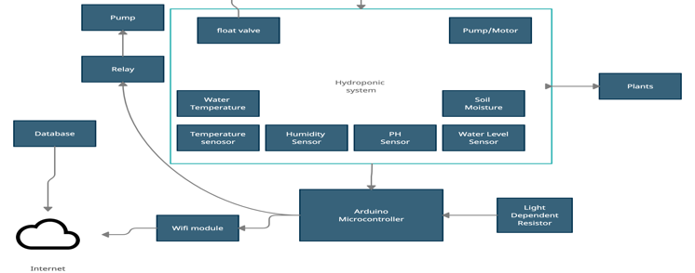

Figure 5:Architecture Diagram

*Hydroponic Farming*

In the present fast pace world, the form of hydroponic farming is taking over. The ongoing research paved new ways and paths for a better and substantial way of farming. Noticing the ways and researching the present trends, mainly followed in metropolitan cities and  technologically advanced countries makes lives a lot easier in terms of  hydroponic farming.

The work done by us addresses the key issues of automation and IoT integration into the way of sustainable farming in constraints such as limited water supply and space.

**Water-Level Sensor** : A water-level sensor is a device used in the detection of the water level. Maintaining Water level helps the root absorb correct amount of water and makes sure that the plant doesn't gets spoiled.

**pH Sensor** : Optimal pH levels are critical to healthy plants and high yields in both soil and hydroponics gardening. Maintaining those optimal levels, especially in soilless growing systems, calls for frequent, accurate pH testing. Ideal pH levels maximize a plant’s nutrient uptake. Those nutrients, in turn, increase a plant’s vigor and productivity.

**Soil Moisture Sensor** : This soil moisture sensor can be used to detect the moisture of soil or judge if there is water around the sensor, let's you know if the plants in the mesh pot require water or not. The units used in calculating is bars.

**DHT22 Temperature/Humidity Sensor** : The DHT22 is a humidity and temperature sensor with a single wire digital interface. The sensor is calibrated so you can get right to measuring relative humidity and temperature.

**Luminous Intensity Sensor** : Helps to capture the amount of sunlight hitting the product

**3.3) Proposed system model**

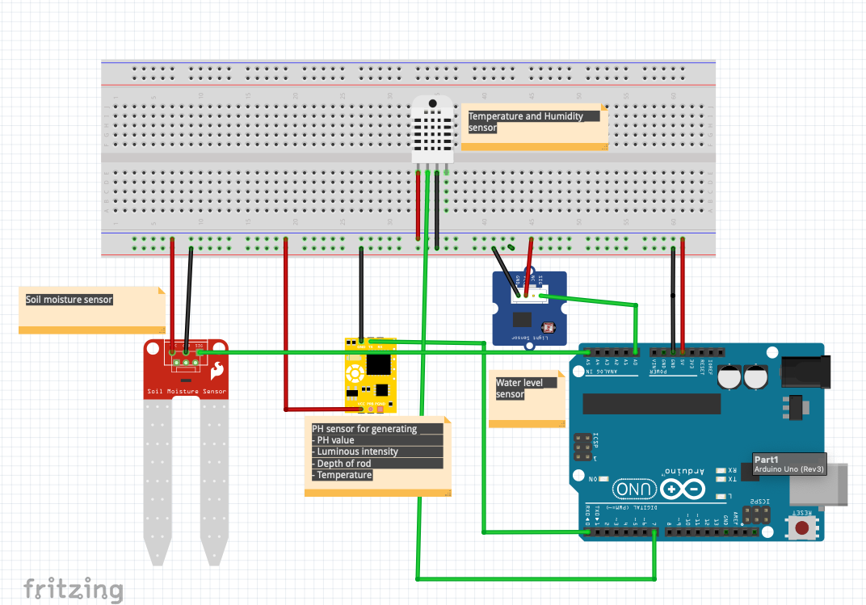

Figure 6:Circuit Diagram of System

|  |  |  |
| --- | --- | --- |
| Sensor connection from Arduino | | |
|  |  |  |
| SENSOR | FROM | TO |
| PH SENSOR | TX | RX |
| VCC | VCC |
| GND | GND |
| DHT 22 |  |  |
| VCC | VCC |
| GND | GND |
| SOIL MOISTURE | DATA | A1 |
| VCC | VCC |
| GND | GND |
| WATER LEVEL SENSOR | DATA | A2 |
| VCC | VCC |
| GND | GND |

Table 2:Pin Diagram for Circuit

# 4) Design Approach and Details

**4.1) Introduction**

The work being done needs constant monitoring as various sensors are used in an confined and controlled environment. As pre-processing homo sapiens , we tend to make unavoidable errors in our work. To avoid such mistakes that in other ways cannot be avoided, automation is the way.

**4.2) Requirement Analysis**

With the help of Arduino , ESp 8266 and aurd Spread Sheet the reading from the sensors are directly stored into the spreads sheet with almost no error. The readings are recorded once every 10 minutes which without automation requires a immense amount of man power which intern may lead to loss or errors in recorded results.

Farming mainly depends on ambient climatic conditions but the city environment is not suitable for the growth of crops in the traditional way.

For our work as we targeted the metropolitan cities we made sure that the temperature rage varied from 28 degree Celsius to 36 degree Celsius. In hydroponic farming, the crops are not exposed to sunlight throughout. Rather than exposing them to sunlight throughout, we made sure that an adequate sunlight was available which in the day reaches approximately 240 candela and in the night for the integrity of the results, we made sure no light from any source was available which resulted in 0 candela.

Speaking about the soil moisture, for better understating of the impact of moisture retention of the soil we grew the crops in early summer because of which there is humidity in the air than normal. The humidity varied from 40 percent to 80 percent which is the normal range in a coastal city.

All the information collected from the sensors is stored in the personal systems directly rather than cloud as clod is heavily dependent upon an uninterrupted internet connection which sometimes may not be possible.

The data collected is stored and processed with the help of python to create results which help in better understanding of the data.

4.2.1) Functional Requirements

4.2.1.1)  *Product Perspective:*

 The product is aimed to assess and predict the best possible scenarios which help in the growth of the crops with good yield. This can mainly be used to know the optimal conditions to grow the crops in restricted conditions especially in a city environment. The key aspect of this work is predicting the optimal condition for growth when few parameters are already bound.

4.2.1.2)  *Product Features*

This work has features like an automated irrigation system, which as the name suggests automatically supplies water and other essential nutrients for plant growth once set up. The other features are predicting optimal requirements with the help of regression models and correlation when one or more of the parameters are bound.

4.2.1.3)   *User Characteristics*

The user gets an interface in which he or she can enter the bound variables and set some required parameters which the automated system takes into account and does the rest.

4.2.1.4)    *Assumption and Dependencies*

This work makes an assumption that the user has at least a minimal knowledge on the dos and don'ts of farming and how to use, read and setup sensors required.

4.2.1.5)    *Domain Requirements*

The work done requires the automated irrigation system to cut out the supply when the readings are not in the optimal range. It also has an app which has controls that stops the system when required.

4.2.1.6)     *User Requirements*

The user is required to have uninterrupted power supply to the system as any power loss wouldn’t damage the system but would lead to loss in the readings. Also, the user must have a smart which will give him constant updates and control over the system.

4.2.2) Non Functional Requirements

4.2.2.1) *Efficiency*

The efficiency of the system can not be counted as a whole but can be counted when correlated with other parameters, it can be calculated as four terms. The parameters that are correlated are then made into a set for the better result of the growth.

4.2.2.2) Reliability

The model has a very good reliability for a prototype. When considering the data set, around 30 odd seeds were planted out of which around 22 seeds gave yield which generally means 70% efficiency and pretty high reliability.

4.2.2.3) Portability

As this project is highly revolving around farming, portability is next to impossible. But, the setup of sensors and actuators used for taking readings is very portable. It is just a set of sensors and a smartphone.

4.2.3) System Requirements

4.2.3.1) *Hardware Requirements*

* Arduino Mega 2560
* Temperature sensor (DHT-22)
* Humidity Sensor (DHT-22)
* Water Level Sensor
* Soil Moisture Sensor
* PH Sensor
* Luminous Intensity Sensor
* WIFI module (ESP 8266)
* Breadboard
* Jumper wires
* Pump
* Water Tube
* 5V motor
* 5V power supply

4.2.3.2) *Software Requirements*

* Python Version 3.9.0
* Sklearn (Machine learning Library and Evaluation )
* Pandas (Handling CSV files)
* Numpy (Handling Arrays in python)
* Arduino Software (To upload code to UNO board)
* MAC OS version 11.6 128GB storage
* VS code editor

# 5) Results and Discussion

**5.1) Gantt Chart**

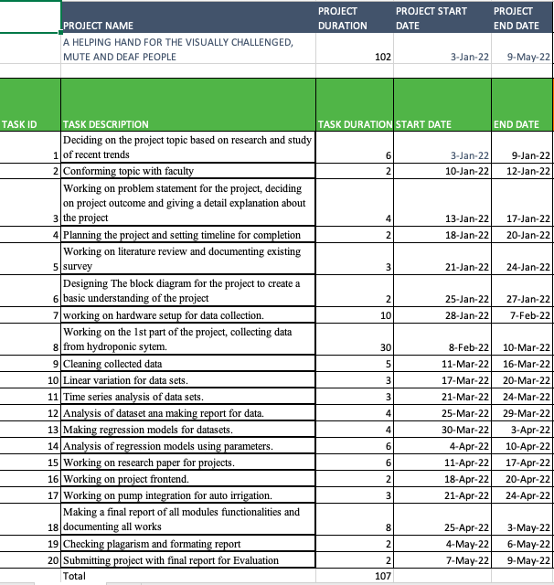

Figure 7: Gantt chart for project

**5.2) Time series of project**

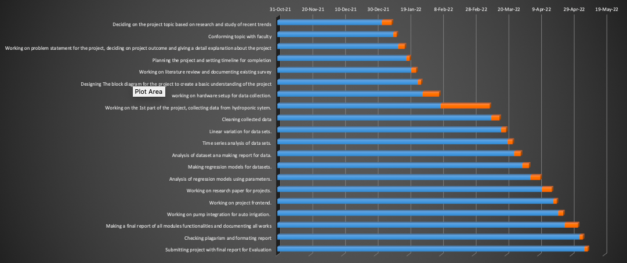

Figure 8: Time Line for project

# 6) Results and Discussion

The main objective of the result is to corelate the various parameters of the experiments with the help of four evaluation parameters, namely

* Mean Absolute Error (MAE)
* Root Mean Square Error (MASE)
* Root Mean Square Log Error (RMSE)
* R Squared(R2)

The lower the value of MAE, the more the parameters are corelated. The R2 specifies the error in the calculations I,e the lesser the value of R2, the better the correlation is.

**6.1) Dataset and dataset analysis**

All the information collected from the sensors is stored in the personal systems directly rather than cloud as clod is heavily dependent upon an uninterrupted internet connection which sometimes may not be possible.

The data collected is stored and processed with the help of python to create results which help in better understanding of the data.

Analysis of phase 1 (planting phase)

Range of parameters

|  |  |  |
| --- | --- | --- |
| PARAMETER | MAX | MIN |
| PH | 8.37 | 4.23 |
| LUMINOUS INTENSITY | 228 | 0 |
| HUMIDITY | 76.2 | 50.3 |
| TEMPERATURE | 34.6 | 25.5 |
| SOIL MOISTURE | 687 | 676 |
| WATER LEVEL | 252 | 161 |

Table 3:Range of parameters Phase-1

Dataset Description

|  |  |
| --- | --- |
| TYPE | DESCRIPTION |
| Data set Characteristic | Multivariant |
| Attribute Characteristics | Timestamp, Integer, Real |
| Associated Tasks | Regression |
| Number of Instances | 469 |
| Number of attributes | 841 |

Table 4:Dataset Description Phase-1

Attribute Information

1. Day(1-28)
2. Timestamp(HH:MM:SS)
3. Ph value
4. Luminous intensity
5. Humidity
6. Temperature
7. Water level
8. Soil Moisture

Analysis of phase 2 (Growing phase)

Range of parameters

|  |  |  |
| --- | --- | --- |
| PARAMETER | MAX | MIN |
| PH | 27.13 | 6.68 |
| LUMINOUS INTENSITY | 226 | 0 |
| HUMIDITY | 82.5 | 47.8 |
| TEMPERATURE | 38.6 | 25.7 |
| SOIL MOISTURE | 687 | 579 |
| WATER LEVEL | 731 | 153 |

Table 5:Range of parameters Phase-2

Dataset Description

|  |  |
| --- | --- |
| TYPE | DESCRIPTION |
| Data set Characteristic | Multivariant |
| Attribute Characteristics | Timestamp, Integer, Real |
| Associated Tasks | Regression |
| Number of Instances | 841 |
| Number of attributes | 8 |

Table 6:Dataset Description Phase-2

Attribute Information

1. Day(1-28)
2. Timestamp(HH:MM:SS)
3. Ph value
4. Luminous intensity
5. Humidity
6. Temperature
7. Water level
8. Soil Moisture

Analysis of phase 3 (Harvesting phase)

Range of parameters

|  |  |  |
| --- | --- | --- |
| PARAMETER | MAX | MIN |
| PH | 12.59 | 0 |
| LUMINOUS INTENSITY | 220 | 0 |
| HUMIDITY | 72.7 | 43.6 |
| TEMPERATURE | 36.3 | 27.7 |
| SOIL MOISTURE | 685 | 676 |
| WATER LEVEL | 661 | 272 |

Table 7:Range of parameters phase-3

Dataset Description

|  |  |
| --- | --- |
| TYPE | DESCRIPTION |
| Data set Characteristic | Multivariant |
| Attribute Characteristics | Timestamp, Integer, Real |
| Associated Tasks | Regression |
| Number of Instances | 250 |
| Number of attributes | 8 |

Table 8:Dataset description Phase-3

Attribute Information

1. Day(1-28)
2. Timestamp(HH:MM:SS)
3. Ph value
4. Luminous intensity
5. Humidity
6. Temperature
7. Water level
8. Soil Moisture

Analysis of full phase of data

Range of parameters

|  |  |  |
| --- | --- | --- |
| PARAMETER | MAX | MIN |
| PH | 27.13 | 0 |
| LUMINOUS INTENSITY | 228 | 0 |
| HUMIDITY | 82.5 | 43.6 |
| TEMPERATURE | 38.6 | 25.5 |
| SOIL MOISTURE | 693 | 676 |
| WATER LEVEL | 731 | 153 |

Table 9:Range of parameters full data

Dataset Description

|  |  |
| --- | --- |
| TYPE | DESCRIPTION |
| Data set Characteristic | Multivariant |
| Attribute Characteristics | Timestamp, Integer, Real |
| Associated Tasks | Regression |
| Number of Instances | 1559 |
| Number of attributes | 8 |

Table 10:Range of Parameters full data

Attribute Information

1. Day(1-28)
2. Timestamp(HH:MM:SS)
3. Ph value
4. Luminous intensity
5. Humidity
6. Temperature
7. Water level
8. Soil Moisture

**6.2) Linear Variation between parameters in dataset**

|  |  |  |
| --- | --- | --- |
| PARAMETERS | CHART | OBSERVATION |
| PH |  | * The minimum value recorded is 5.5 on the ph scale and this was recorded during the Initial phase of the experiment. * The maximum recorded is 13 and it was recorded during the growth phase due to the addition of mineral water to the water supply, it became more basic. * After the growth phase we supplied general water again so, the pH dropped gradually making it more neutral. * Ideally the crop grows in soil’s with a PH value of 7-8 which has been followed in the hydroponic system. |
| LUMINOUS INTENSITY |  | * The least recorded is Zero as during the night, it is made sure that the experimental setup is not exposed to any form of light energy. * The highest value recorded is around 250 candela during the day. * The recorded values only account for the amount of sunlight received by the crop. * Ideally the crops grown in field receives sunlight from 225-250 candela which has been the case for an hydroponic system as well. |
| HUMIDITY |  | * The humidity in the surroundings of the setup. * As the experiment setup was in a coastal city, the humidity is relatively high but is under the normal humidity levels for the city. * The lowest recoded is 45% and the highest is around 80%. * To make sure that the humidity level doesn’t go overboard, we conducted the experiment during early summer. |
| TEMPERATURE |  | * The temperature kept on raising during the experiment gradually. * The lowest recoded temperature was 26 degree Celsius and highest was 36 degree Celsius. * The lowest average temperature was during the initial phase and the highest average was during the harvesting phase. * The ideal temperature for crops the grow is 28-32 degrees which has been mostly observed in our system. |
| SOIL MOISTURE |  | * During the initial phase the moisture level was between 682-686. * The moisture level was highest during the growth phase which ranges between 680-692. * The moisture level during the harvest phase is lowest in terms of average, its range varies from 676-680. * Soil moisture is normally very high in a hydroponic system and even with high temperature the coco pit was able to retain moisture and keep the soil moisture constant throughout the growth of the crop. |
| WATER LEVEL |  | * The water level gradually increases till the growth phase and decreases there on. * The water level during the initial phase was between 160 and 240ml, during growth phase it is between 200ml and 650ml. * During the harvest phase, the water level required is low , it ranges from 200-500ml. * The trends were similar to crops grown in fields hence it will be ideal for plants to grow easily In a city based hydroponic system. |

Table 11:Linear variation of parameters with respect to time

**Variation of PH with other parameters**

|  |  |  |  |  |
| --- | --- | --- | --- | --- |
| PARAMETER | Initial  Phase | Growing  Phase | Harvesting  Phase | Full  Phase |
| Sunlight |  |  |  |  |
| Humidity |  |  |  |  |
| Temperature |  |  |  |  |
| Soil Moisture |  |  |  |  |
| Water level |  |  |  |  |

Table 12:Linear variation of Ph with other parameters

**Variation of Water Level with other parameters**

|  |  |  |  |  |
| --- | --- | --- | --- | --- |
| PARAMETER | Initial  Phase | Growing  Phase | Harvesting  Phase | Full  Phase |
| Sunlight |  |  |  |  |
| Humidity |  |  |  |  |
| Temperature |  |  |  |  |
| Soil Moisture |  |  |  |  |
| PH |  |  |  |  |

Table 13:Linear Variation of water level with other parameters

**Variation of Sunlight with other parameters**

|  |  |  |  |  |
| --- | --- | --- | --- | --- |
| PARAMETER | Initial  Phase | Growing  Phase | Harvesting  Phase | Full  Phase |
| PH |  |  |  |  |
| Humidity |  |  |  |  |
| Temperature |  |  |  |  |
| Soil Moisture |  |  |  |  |
| Water Level |  |  |  |  |

Table 14:Linear variation of sunlight with other parameters

**Variation of Temperature with other parameters**

|  |  |  |  |  |
| --- | --- | --- | --- | --- |
| PARAMETER | Initial  Phase | Growing  Phase | Harvesting  Phase | Full  Phase |
| Sunlight |  |  |  |  |
| Humidity |  |  |  |  |
| PH |  |  |  |  |
| Soil Moisture |  |  |  |  |
| Water Level |  |  |  |  |

Table 15:Linear variation of temperature with other parameters

**Variation of Humidity with other parameters**

|  |  |  |  |  |
| --- | --- | --- | --- | --- |
| PARAMETER | Initial  Phase | Growing  Phase | Harvesting  Phase | Full  Phase |
| Sunlight |  |  |  |  |
| PH |  |  |  |  |
| Temperature |  |  |  |  |
| Soil Moisture |  |  |  |  |
| Water Level |  |  |  |  |

Table 16:Linear variation of humidity with other parameters

**Variation of Soil Moisture with other parameters**

|  |  |  |  |  |
| --- | --- | --- | --- | --- |
| PARAMETER | Initial  Phase | Growing  Phase | Harvesting  Phase | Full  Phase |
| Sunlight |  |  |  |  |
| Humidity |  |  |  |  |
| Temperature |  |  |  |  |
| PH |  |  |  |  |
| Water Level |  |  |  |  |

Table 17:Linear variation of soilmoisture with other parameters

## 6.3) Predictive Analysis of parameters using Linear Regression

|  |  |  |  |  |  |  |
| --- | --- | --- | --- | --- | --- | --- |
| PARAMETER VS PARAMETER | PH | SUNLIGHT | HUMIDITY | TEMPERATURE | SOILMOISTURE | WATER LEVEL |
| PH | X | MAE=26.54 MASE=1702.59 RMSE=41.26 R2=-0.00288 | MAE=3.13 MASE=17.055 RMSE=4.1298 R2= 0.03718 | MAE=0.9522 MASE=2.0584 RMSE=1.43474 R2=-0.003785 | MAE=0.9161 MASE=1.1950 RMSE=1.0931 R2=-0.011836 | MAE= 11.9423. MASE= 233.031 RMSE= 15.265 R2=-0.0039 |
| SUNLIGHT | MAE=0.3905 MASE= 0.2885 RMSE= 0.5371 R2= -0.00707 | X | MAE= 2.9133 MASE= 16.551 RMSE= 4.0683 R2= 0.0650 | MAE= 0.7492 MASE= 1.268 RMSE= 1.126 R2= 0.145 | MAE=0.902 MASE=1.160 RMSE= 1.077 R2=-0.0417 | MAE=1.0388 MASE= 1.521 RMSE= 1.233 R2=0.078 |
| HUMIDITY | MAE=0.3817 MASE=0.253 RMSE= 0.503 R2=-0.0074 | MAE=21.29 MASE= 1630.14 RMSE= 40.375 R2= 0.157 | X | MAE= 0.831 MASE= 1.205 RMSE= 1.097 R2= 0.517 | MAE=0.875 MASE=1.06 RMSE=1.033 R2= -0.0056 | MAE=9.843 MASE=174.68 RMSE=13.21 R2=0.0941 |
| TEMPERATURE | MAE=0.409 MASE=0.316 RMSE= 0.562 R2=0.0032 | MAE=22.06 MASE=1529.58 RMSE=39.109 R2=0.216 | MAE=2.64 MASE=10.3 RMSE=3.214 R2=0.505 | X | MAE=0.9160 MASE=1.190 RMSE=1.090 R2=-0.012 | MAE=9.714 MASE=168.86 RMSE=12.99 R2=0.087 |
| SOILMOISTURE | MAE= 0.389 MASE= 0.278 RMSE= 0.527 R2= = -0.0094 | MAE=24.12 MASE= 1462.23 RMSE= 38.23 R2=0.0032 | MAE= 0.933 MASE=2.1119 RMSE= 1.453 R2= -0.0231 | MAE=2.890 MASE=15.77 RMSE= 3.97 R2=-0.018 | X | MAE=11.212 MASE=229.93 RMSE= 15.16 R2= -0.0049 |
| WATER LEVEL | MAE= 0.339 MASE=0.232 RMSE=0.4819 R2=0.0221 | MAE= 22.450 MASE= 1350.67 RMSE= 36.75 R2= 0.190 | MAE= 3.35 MASE=2.043 RMSE=1.4296 R2=0.0010 | MAE=3.356 MASE=18.41 RMSE=4.29 R2=0.039 | MAE=0.797 MASE=1.540 RMSE= 1.240 R2= 0.0032 | X |

Table 18:Linear Regression Between Parameters for Initial Phase of Coriander Plant Growth

From Table 5, it can be inferred that water level and pH are the most corelated parameters in the initial phase of the experiment as MAE=0.339. This means, with a given Water Level, we can predict the value of pH required for a good yield. The parameters that cannot be corelated are pH and Sunlight as the MAE=26.54, this means that the value of Luminous intensity cannot be predicted with the pH level.

|  |  |  |  |  |  |  |
| --- | --- | --- | --- | --- | --- | --- |
| PARAMETER VS PARAMETER | PH | SUNLIGHT | HUMIDITY | TEMPERATURE | SOILMOISTURE | WATER LEVEL |
| PH | X | MAE=21.157 MASE=1228.42 RMSE=35.04 R2=-0.0048 | MAE=3.400 MASE=21.329 RMSE=4.618 R2= -0.0108 | MAE=1.155 MASE=3.1804 RMSE=1.783 R2=-0.0061 | MAE=1.6315 MASE=3.9975 RMSE=1.999 R2=0.0096 | MAE= 136.46. MASE= 23789.17 RMSE= 154.2 R2=0.1199 |
| SUNLIGHT | MAE=0.944 MASE= 2.5054 RMSE= 1.582 R2= 0.0000523 | X | MAE= 3.309 MASE= 20.457 RMSE= 4.522 R2=0.194 | MAE= 1.010 MASE= 2.544 RMSE= 1.595 R2= 0.1704 | MAE=1.556 MASE=3.836 RMSE= 1.958 R2=0.0247 | MAE=1.562 MASE= 3.678 RMSE= 1.917 R2=0.033 |
| HUMIDITY | MAE=0.9677 MASE=2.328 RMSE= 1.525 R2=0.00814 | MAE=19.44 MASE= 1072.59 RMSE= 32.750 R2= 0.1304 | X | MAE= 0.943 MASE= 1.686 RMSE= 1.298 R2= 0.5603 | MAE=1.6009 MASE=3.845 RMSE=1.96 R2= 0.00245 | MAE=134.715 MASE=24155.87 RMSE=155.42 R2=0.1037 |
| TEMPERATURE | MAE=0.8932 MASE=1.6079 RMSE=1.268 R2=-0.0076 | MAE=18.107 MASE=888.58 RMSE=29.80 R2=0.165 | MAE=2.487 MASE=10.05 RMSE=3.171 R2=0.563 | X | MAE=1.780 MASE=4.511 RMSE=2.123 R2=-0.0042 | MAE=142.16 MASE=25289.25  RMSE=159.02 R2=0.0057 |
| SOILMOISTURE | MAE= 0.959 MASE= 2.385 RMSE= 1.544 R2= = 0.01081 | MAE=19.289 MASE= 834.443 RMSE= 28.88 R2=0.0037 | MAE= 1.0317 MASE=2.1168 RMSE=1.454 R2= -0.0373 | MAE=3.3324 MASE=21.27 RMSE= 4.612 R2=-0.00273 | X | MAE=130.00 MASE=23137.316  RMSE= 152.109  R2= 0.0110 |
| WATER LEVEL | MAE= 0.886 MASE=2.728 RMSE=1.65 R2=0.1177 | MAE= 20.0011 MASE= 1183.82 RMSE= 34.406 R2= 0.0038 | MAE= 1.563 MASE=3.701 RMSE= 1.923 R2=0.0199 | MAE=3.494 MASE=20.4542 RMSE=4.5226 R2=0.073 | MAE=1.173 MASE=2.624 RMSE= 1.62 R2= 0.0017 | X |

Table 19:Linear Regression Between Parameters for Growing Phase of Coriander Plant Growth

From Table 6, it can be inferred that temperature and pH are the most corelated parameters in the growth phase of the experiment as MAE=0.8932. This means, with a given temperature, we can predict the value of pH required for a good yield. The parameters that cannot be corelated are temperature and water level as the MAE=142.16, this means that the value of Water level cannot be predicted with a given temperature.

|  |  |  |  |  |  |  |
| --- | --- | --- | --- | --- | --- | --- |
| PARAMETER VS PARAMETER | PH | SUNLIGHT | HUMIDITY | TEMPERATURE | SOILMOISTURE | WATER LEVEL |
| PH | X | MAE=22.685 MASE=1027.818 RMSE=32.059 R2=-0.020 | MAE=4.589 MASE=33.367 RMSE=5.77 R2= -0.154 | MAE=0.906 MASE=1.836 RMSE=1.35 R2=0.0653 | MAE=1.1328 MASE=1.821 RMSE=1.349 R2=0.032 | MAE= 100.54. MASE=15723.309 RMSE= 125.392 R2=-0.05177 |
| SUNLIGHT | MAE=0.9731 MASE= 1.421 RMSE= 1.192 R2= -0.0967 | X | MAE= 3.446 MASE= 20.575 RMSE= 4.535 R2= 0.1587 | MAE= 0.7630 MASE=1.6451 RMSE= 1.282 R2= 0.2184 | MAE=0.945 MASE=1.470 RMSE= 1.212 R2=-0.0047 | MAE=1.0651 MASE= 1.972 RMSE= 1.404 R2=0.00676 |
| HUMIDITY | MAE=0.8707 MASE=1.2903 RMSE= 1.1359 R2=0.153 | MAE=19.1465 MASE= 1114.27 RMSE= 33.38 R2= 0.205 | X | MAE=0.725 MASE= 1.277 RMSE= 1.130 R2= 0.290 | MAE=1.008 MASE=1.796 RMSE=1.340 R2= 0.01474 | MAE=108.25 MASE=14820.36 RMSE=121.738 R2=0.207 |
| TEMPERATURE | MAE=0.9607 MASE=1.441 RMSE=1.2004 R2=0.075 | MAE=20.242 MASE=1750.404 RMSE=41.837 R2=0.2634 | MAE=3.8819 MASE=25.495 RMSE=5.049 R2=0.3559 | X | MAE=1.130 MASE=2.060 RMSE=1.435 R2=0.00103 | MAE=111.24 MASE=16898.54RMSE=129.99 R2=0.026065 |
| SOILMOISTURE | MAE= 0.9433 MASE= 2.2974 RMSE= 1.515 R2= = -0.0189 | MAE=23.149 MASE= 1434.32 RMSE= 37.87 R2=-0.00766 | MAE= 1.0291 MASE=1.813 RMSE= 1.346 R2= -0.1067 | MAE=4.599 MASE=33.304 RMSE= 5.770 R2=-0.0732 | X | MAE=105.00 MASE=16357.032 RMSE=127.894 R2= -0.004 |
| WATER LEVEL | MAE= 0.9163 MASE=1.311 RMSE=1.145 R2=0.0459 | MAE= 28.312 MASE= 2365.95 RMSE= 48.641 R2= 0.000481 | MAE=1.055 MASE=1.63225 RMSE=1.2775 RE=0.0771 | MAE=4.03624 MASE= 25.24 RMSE=5.024 R2=0.16178 | MAE=0.9096 MASE=1.342 RMSE= 1.158 R2= 0.0436 | X |

Table 20:Linear Regression Between Parameters for Harvesting Phase of Coriander Plant Growth

From Table 7, it can be inferred that humidity and temperature are the most corelated parameters in the harvesting phase of the experiment as MAE=0.723. This means, with a given humidity level, we can predict the temperature required for a good yield. The parameters that cannot be corelated are temperature and water level as the MAE=111.24, this means that the value of Water level cannot be predicted with a given temperature.

Table 21: Linear Regression Between Parameters for Full Phase of Coriander Plant Growth

|  |  |  |  |  |  |  |
| --- | --- | --- | --- | --- | --- | --- |
| PARAMETER VS PARAMETER | PH | SUNLIGHT | HUMIDITY | TEMPERATURE | SOILMOISTURE | WATER LEVEL |
| PH | X | MAE=23.313 MASE=1591.03 RMSE=39.88 R2=0.00118 | MAE=3.9601 MASE=27.939 RMSE=5.285 R2= 0.00598 | MAE=1.210 MASE=3.0650 RMSE=1.750 R2=0.0599 | MAE=1.8210 MASE=4.899 RMSE=2.213 R2=0.0378 | MAE= 137.684 MASE= 22732.459 RMSE= 150.772 R2=0.2893 |
| SUNLIGHT | MAE=1.0360 MASE= 2.128 RMSE= 1.459 R2= -0.000246 | X | MAE= 3.419 MASE= 21.26 RMSE= 4.61 R2= 0.157 | MAE= 1.147 MASE= 2.604 RMSE= 1.613 R2= 0.185 | MAE=1.921 MASE=5.188 RMSE= 2.277 R2=-0.0118 | MAE=1.8404 MASE= 4.6457 RMSE=2.155 R2=-0.0026 |
| HUMIDITY | MAE=0.9411 MASE=1.633 RMSE= 1.278 R2=0.0245 | MAE=20.003 MASE= 1241.13 RMSE= 35.22 R2= 0.1857 | X | MAE= 0.929 MASE= 1.478 RMSE= 1.216 R2= 0.375 | MAE=1.811 MASE=4.672 RMSE=2.161 R2= 0.023 | MAE=165.664 MASE=31591.99 RMSE=31591.99 R2=0.02649 |
| TEMPERATURE | MAE=0.9259 MASE=2.554 RMSE= 1.598 R2=0.0676 | MAE=20.468 MASE=1358.52 RMSE=36.85 R2=0.176 | MAE=3.1046 MASE=16.046 RMSE=4.005 R2=0.4775 | X | MAE=1.658 MASE=4.024 RMSE=2.006 R2=0.0590 | MAE=166.6700 MASE=31745.512 RMSE=178.172 R2=0.0422 |
| SOILMOISTURE | MAE= 0.936 MASE= 1.618 RMSE= 1.27 R2= =0.113 | MAE=22.930 MASE= 1473.35 RMSE= 38.23 R2=-0.0140 | MAE=1.185 MASE=3.058 RMSE= 1.748 R2= 0.0505 | MAE=3.6435 MASE=24.41 RMSE= 4.94 R2=0.0159 | X | MAE=125.65 MASE=22858.07 RMSE= 151.18 R2= 0.288 |
| WATER LEVEL | MAE= 0.850 MASE=1.518 RMSE=1.23 R2=0.2719 | MAE= 23.489 MASE= 1536.91 RMSE= 39.20 R2= 0.0056 | MAE= 3.864 MASE= 28.33 RMSE= 5.322 R2= 0.0316 | MAE=1.185 MASE=2.916 RMSE=1.707 R2=0.0823 | MAE=1.451 MASE=3.329 RMSE= 1.824 R2= 0.3089 | X |

Table 22:Linear Regression Between Parameters for Full Phase of Coriander Plant Growth

From Table 8, it can be inferred that water level and pH are the most corelated parameters in the full phase analysis of the experiment as MAE=0.850. This means, with a given water level, we can predict the pH required for a good yield. The parameters that cannot be corelated are temperature and water level as the MAE=166.67, this means that the value of Water level cannot be predicted with a given temperature.

## Predictive Analysis of parameters using Support Vector Regression

|  |  |  |  |  |  |  |
| --- | --- | --- | --- | --- | --- | --- |
| PARAMETER VS PARAMETER | PH | SUNLIGHT | HUMIDITY | TEMPERATURE | SOILMOISTURE | WATER LEVEL |
| PH | X | MAE=22.102 MASE=2351.64 RMSE=48.493 R2=-0.0852 | MAE=2.9432 MASE=15.363 RMSE=3.919 R2= 0.2227 | MAE=0.82803 MASE=1.598 RMSE=1.2642 R2=0.0446 | MAE=0.8812 MASE=1.423 RMSE=1.193 R2=-0.174 | MAE= 10.6116 MASE= 218.732 RMSE= 14.789 R2=-0.0377 |
| SUNLIGHT | MAE=0.3460 MASE= 0.227 RMSE= 0.4766 R2= -0.0458 | X | MAE= 2.836 MASE=13.770 RMSE= 3.710 R2= 0.264 | MAE= 0.518 MASE= 0.871 RMSE= 0.933 R2= 0.450 | MAE=0.8686 MASE=1.362 RMSE= 1.167 R2=-0.120 | MAE=0.989 MASE= 1.627 RMSE= 1.275 R2=-0.225 |
| HUMIDITY | MAE=0.310 MASE=0.174 RMSE= 0.417 R2=0.275 | MAE=17.27 MASE= 1259.407 RMSE= 35.48 R2= 0.0078 | X | MAE= 0.683 MASE= 0.825 RMSE=0.908 R2= 0.3423 | MAE=0.833 MASE=1.378 RMSE=1.174 R2= -0.057 | MAE=9.329 MASE=169.081 RMSE=13.0031 R2=0.0302 |
| TEMPERATURE | MAE=0.396 MASE=0.317 RMSE= 0.563 R2=0.00755 | MAE=13.68 MASE=1172.59 RMSE=34.24 R2=0.2142 | MAE=2.742 MASE=11.737 RMSE=3.425 R2=0.466 | X | MAE=0.842 MASE=1.325 RMSE=1.151 R2=-0.1810 | MAE=7.9547 MASE=137.199 RMSE=11.713 R2=0.25006 |
| SOILMOISTURE | MAE= 0.348 MASE= 0.199 RMSE= 0.4461 R2= = -0.0110 | MAE=20.962 MASE= 2052.051 RMSE= 45.299 R2=-0.0695 | MAE=3.7415 MASE=23.297 RMSE=4.8267 R2= -0.0293 | MAE=0.896 MASE=1.852 RMSE= 1.3611 R2=-0.1329 | X | MAE=8.9695 MASE=161.8012 RMSE= 12.7201 R2= -0.00836 |
| WATER LEVEL | MAE= 0.359 MASE=0.2667 RMSE=0.5165 R2=-0.0788 | MAE= 23.2524 MASE= 2417.059 RMSE= 49.1636 R2=0.0059 | MAE= 2.9750 MASE=16.440 RMSE=4.05465 R2=0.02438 | MAE=1.00006 MASE=2.70294 RMSE=1.6440 R2=0.1164 | MAE=0.7492 MASE=1.0809 RMSE= 1.0396 R2= -0.1662 | X |

Table 23:Support Vector Regression Between Parameters for Initial Phase of Coriander Plant Growth

From Table 9, it can be inferred that humidity and pH are the most corelated parameters in the initial phase of the experiment as MAE=0.310. This means, with a given humidity level, we can predict the pH required for a good yield. The parameters that cannot be corelated are water level and sunlight as the MAE=23.025, this means that the value of Water level cannot be predicted with a given luminous intensity.

|  |  |  |  |  |  |  |
| --- | --- | --- | --- | --- | --- | --- |
| PARAMETER VS PARAMETER | PH | SUNLIGHT | HUMIDITY | TEMPERATURE | SOILMOISTURE | WATER LEVEL |
| PH | X | MAE=17.013 MASE=1014.28 RMSE=31.84 R2=-0.0743 | MAE=3.8003 MASE=25.36 RMSE=5.0361 R2= 0.0470 | MAE=0.995 MASE=2.330 RMSE=1.526 R2=0.1112 | MAE=1.638 MASE=4.429 RMSE=2.104 R2=0.0109 | MAE= 120.94.  MASE= 24176.55  RMSE= 155.48  R2=0.026 |
| SUNLIGHT | MAE=1.005 MASE= 4.719 RMSE= 2.172 R2= -0.0719 | X | MAE= 3.602 MASE=23.974 RMSE=4.896 R2= 0.1506 | MAE= 0.802 MASE=1.444 RMSE=1.2019 R2=0.430 | MAE=1.6199 MASE=4.0536 RMSE=2.013 R2=0.0220 | MAE=139.698  MASE=29287.10 RMSE=171.134  R2=-0.1414 |
| HUMIDITY | MAE=0.822 MASE=1.879 RMSE= 1.370 R2=-0.0892 | MAE=17.210 MASE=1090.04 RMSE=33.015 R2= 0.0421 | X | MAE=0.745 MASE=0.958 RMSE=0.979 R2= 0.7400 | MAE=1.749 MASE=4.602 RMSE=2.1453 R2=0.0295 | MAE=134.739  MASE= 24557.95 RMSE=156.709  R2=-0.0675 |
| TEMPERATURE | MAE=0.839 MASE=1.934 RMSE=1.391 R2=-0.0447 | MAE=18.473 MASE=1451.83 RMSE=38.102 R2=0.1318 | MAE=2.618 MASE=11.78 RMSE=3.43 R2=0.572 | X | MAE=1.564 MASE=3.69 RMSE=1.922 R2=0.0255 | MAE=139.68 MASE=26889.48  RMSE=163.980 R2=-0.00359 |
| SOILMOISTURE | MAE= 0.886 MASE= 2.831 RMSE=1.682 R2= -0.037 | MAE=18.183 MASE= 1149.82 RMSE= 33.909 R2=-0.0549 | MAE= 4.1329 MASE=30.32 RMSE= 5.5065 R2= 0.0070 | MAE=1.1566 MASE=3.419 RMSE= 1.84 R2=-0.0083 | X | MAE=136.775 MASE=24782.89 RMSE=157.42 R2=0.0698 |
| WATER LEVEL | MAE=0.5868 MASE=1.542 RMSE=1.241 R2=0.3133 | MAE=17.654 MASE=1008.07 RMSE=31.750 R2=-0.04008 | MAE=3.581 MASE=24.307 RMSE=4.930 R2=0.1196 | MAE=1.176 MASE=3.361 RMSE=1.83 R2=0.0380 | MAE=1.2847 MASE=2.611 RMSE=1.616 R2=0.368 | X |

Table 24:Support Vector Regression Between Parameters for Growing Phase of Coriander Plant Growth

From Table 10, it can be inferred that water level and pH are the most corelated parameters in the growth phase of the experiment as MAE=0.586. This means, with a given water level, we can predict the pH required for a good yield. The parameters that cannot be corelated are temperature and water level as the MAE=139.68, this means that the value of Water level cannot be predicted with a given temperature.

|  |  |  |  |  |  |  |
| --- | --- | --- | --- | --- | --- | --- |
| PARAMETER VS PARAMETER | PH | SUNLIGHT | HUMIDITY | TEMPERATURE | SOILMOISTURE | WATER LEVEL |
| PH | X | MAE=14.519 MASE=1121.40 RMSE=33.487 R2=-0.055 | MAE=3.750 MASE=23.179 RMSE=4.814 R2= 0.2572 | MAE=0.8486 MASE=1.7209 RMSE=1.311 R2=0.0536 | MAE=1.2121 MASE=2.518 RMSE=1.586 R2=0.0438 | MAE= 109.77  MASE= 21901.17  RMSE= 147.99  R2=-0.1792 |
| SUNLIGHT | MAE=0.975 MASE= 1.782 RMSE= 1.334 R2= 0.0502 | X | MAE= 3.642 MASE= 23.84 RMSE= 4.883 R2= 0.2922 | MAE= 0.5587 MASE= 0.9602 RMSE= 0.979 R2= 0.537 | MAE=1.033 MASE=1.731 RMSE= 1.315 R2=-0.109 | MAE=110.02  MASE=21459.37  RMSE= 146.49  R2=0.334 |
| HUMIDITY | MAE=0.733 MASE=1.0997 RMSE=1.0487 R2=0.1170 | MAE=15.693 MASE= 1416.608 RMSE=37.637 R2=0.1004 | X | MAE=0.6907 MASE=1.549 RMSE=1.244 R2=0.144 | MAE=1.197 MASE=2.227 RMSE=1.492 R2= -0.087 | MAE=112.208  MASE=21545.41  RMSE=146.783  R2=-0.1230 |
| TEMPERATURE | MAE=0.848 MASE=1.307 RMSE= 1.143 R2=-0.0404 | MAE=7.830 MASE=209.74 RMSE=14.482 R2=0.491 | MAE=2.654 MASE=13.02 RMSE=3.609 R2=0.3560 | X | MAE=0.9160 MASE=1.190 RMSE=1.090 R2=-0.012 | MAE=103.405 MASE=18617.395  RMSE=136.445 R2=-0.0513 |
| SOILMOISTURE | MAE=0.908 MASE=1.576 RMSE=1.255 R2=0.0711 | MAE=14.502 MASE=1074.906 RMSE=32.785 R2=-0.0437 | MAE=4.892 MASE=38.307 RMSE=6.189 R2= 0.0917 | MAE=1.027 MASE=2.190 RMSE=1.480 R2=-0.0648 | X | MAE=117.428 MASE=22258.28 RMSE=149.192 R2= 0.1749 |
| WATER LEVEL | MAE=0.868 MASE=2.479 RMSE=1.574 R2=0.069 | MAE=13.670 MASE=525.301 RMSE=22.919 R2= -0.1050 | MAE= 3.9546 MASE=25.571 RMSE=5.056 R2=0.3047 | MAE=0.785 MASE=1.084 RMSE=1.041 R2=-0.011 | MAE=0.9191 MASE=1.329 RMSE= 1.152 R2=0.298 | X |

Table 25:Support Vector Regression Between Parameters for Harvesting Phase of Coriander Plant Growth

From Table 11, it can be inferred that sunlight and temperature are the most corelated parameters in the harvesting phase of the experiment as MAE=0.558. This means, with a given luminous intensity, we can predict the temperature required for a good yield. The parameters that cannot be corelated are soil moisture and water level as the MAE=117.428, this means that the value of Water level cannot be predicted with a soil moisture.

|  |  |  |  |  |  |  |
| --- | --- | --- | --- | --- | --- | --- |
| PARAMETER VS PARAMETER | PH | SUNLIGHT | HUMIDITY | TEMPERATURE | SOILMOISTURE | WATER LEVEL |
| PH | X | MAE=18.38 MASE=1347.984 RMSE=36.71 R2=-0.0432 | MAE=3.538 MASE=22.984 RMSE=4.7942 R2=0.0380 | MAE=1.002 MASE=2.368 RMSE=1.539 R2=0.189 | MAE=1.506 MASE=3.971 RMSE=1.992 R2=0.1733 | MAE= 127.77. MASE= 22839.3 RMSE= 151.12 R2=0.288 |
| SUNLIGHT | MAE=0.9430 MASE= 2.927 RMSE=1.711 R2= -0.00975 | X | MAE= 3.621 MASE= 23.651 RMSE= 4.8632 R2=0.21463 | MAE= 1.111 MASE=2.539 RMSE=1.593 R2= 0.3130 | MAE=1.9406 MASE=5.305 RMSE= 2.3033 R2=-0.0322 | MAE=162.013 MASE= 31499.0 RMSE=177.479 R2=0.0218 |
| HUMIDITY | MAE=0.9039 MASE=1.6860 RMSE=1.298 R2=-0.0062 | MAE=18.2066 MASE=1258.105 RMSE=35.469 R2= 0.0738 | X | MAE= 0.974 MASE= 1.814 RMSE= 1.3470 R2=0.486 | MAE=1.715 MASE=4.422 RMSE=2.102 R2= 0.0019 | MAE=161.61 MASE=30181.06 RMSE=173.72 R2=0.057 |
| TEMPERATURE | MAE=0.898 MASE=2.785 RMSE= 1.668 R2=0.0656 | MAE=18.518 MASE=1583.68 RMSE=39.109 R2=0.115 | MAE=2.86 MASE=13.61 RMSE=3.689 R2=0.4670 | X | MAE=1.609 MASE=4.139 RMSE=2.034 R2=0.0995 | MAE=136.567 MASE=26169.03 RMSE=161.76 R2=0.148 |
| SOILMOISTURE | MAE=0.8068 MASE=1.744 RMSE=1.320 R2=0.0942 | MAE=20.280 MASE=1555.81 RMSE= 39.443 R2=-0.055 | MAE= 3.8521 MASE=27.5794 RMSE= 5.251 R2= 0.0213 | MAE=1.179 MASE=3.128 RMSE= 1.768 R2=0.0436 | X | MAE=110.411 MASE=21951.64 RMSE=148.160 R2= 0.312 |
| WATER LEVEL | MAE= 0.682 MASE=1.331 RMSE=1.153 R2=0.388 | MAE= 19.253 MASE= 1462.55 RMSE= 38.243 R2= -0.0474 | MAE= 3.608 MASE=25.069 RMSE=5.0069 R2=-0.00369 | MAE=1.0911 MASE=2.591 RMSE=1.609 R2=0.1359 | MAE=1.237 MASE=2.696 RMSE= 1.642 R2= 0.4985 | X |

Table 26:Support Vector Regression Between Parameters for Full Phase of Coriander Plant Growth

From Table 12, it can be inferred that water level and pH are the most corelated parameters in the full phase analysis of the experiment as MAE=0.682. This means, with a given water level, we can predict the pH required for a good yield. The parameters that cannot be corelated are sunlight and water level as the MAE=162.013, this means that the value of Water level cannot be predicted with a given luminous intensity.

## Predictive Analysis of parameters using Decision Tree Regression

|  |  |  |  |  |  |  |
| --- | --- | --- | --- | --- | --- | --- |
| PARAMETER VS PARAMETER | PH | SUNLIGHT | HUMIDITY | TEMPERATURE | SOILMOISTURE | WATER LEVEL |
| PH | X | MAE=25.117 MASE=1570.68 RMSE=39.631 R2=-0.0493 | MAE=3.4989 MASE=21.020 RMSE=4.584 R2=0.262 | MAE=1.085 MASE=2.704 RMSE=1.644 R2=-0.415 | MAE=0.952 MASE=1.3727 RMSE=1.171 R2=-0.1289 | MAE=11.330 MASE=266.11 RMSE= 16.312 R2=-0.303 |
| SUNLIGHT | MAE=0.4213 MASE= 0.329 RMSE=0.573 R2= -0.227 | X | MAE= 3.117 MASE=16.69 RMSE=4.085 R2= 0.216 | MAE= 0.637 MASE=1.028 RMSE=1.014 R2=0.5450 | MAE=1.126 MASE=2.266 RMSE=1.505 R2=-0.0655 | MAE=0.996 MASE=1.558 RMSE= 1.248 R2=-0.3035 |
| HUMIDITY | MAE=0.408 MASE=0.292 RMSE=0.541 R2=-0.365 | MAE=36.44 MASE=4653.88 RMSE=68.219 R2=-0.3042 | X | MAE=0.9103 MASE=1.477 RMSE=1.215 R2=0.174 | MAE=1.0399 MASE=2.304 RMSE=1.517 R2=-0.2165 | MAE=11.833 MASE=332.31 RMSE=18.22 R2=-1.0522 |
| TEMPERATURE | MAE=0.389 MASE=0.280 RMSE= 0.529 R2=-0.0033 | MAE=23.802 MASE=2150.406 RMSE=46.37 R2=0.322 | MAE=2.903 MASE=11.880 RMSE=3.446 R2=0.410 | X | MAE=1.1320 MASE=1.858 RMSE=1.363 R2=-0.433 | MAE=8.271 MASE=122.69 RMSE=11.07 R2=0.303 |
| SOILMOISTURE | MAE= 0.406 MASE=0.294 RMSE= 0.542 R2= = -0.0160 | MAE=28.44 MASE= 2407.91 RMSE=49.070 R2=-0.0055 | MAE=3.018 MASE=16.75 RMSE=4.093 R2= -0.020 | MAE=0.7735 MASE=1.104 RMSE=1.050 R2=-0.0059 | X | MAE=11.341 MASE=217.46 RMSE=14.74 R2= -0.205 |
| WATER LEVEL | MAE= 0.334 MASE=0.218 RMSE=0.4672 R2=-0.129 | MAE=21.03 MASE=1526.93 RMSE=39.075 R2=0.2402 | MAE= 3.323 MASE=18.834 RMSE=4.339 R2=0.05843 | MAE=0.919 MASE=2.70294 RMSE=1.5006 R2=0.0072 | MAE=1.0835 MASE=1.879 RMSE=1.3707 R2= -0.5531 | X |

Table 27:Decision Tree Regression Between Parameters for Initial Phase of Coriander Plant Growth

From Table 13, it can be inferred that water level and pH are the most corelated parameters in the initial phase of the experiment as MAE=0.334. This means, with a given water level, we can predict the pH required for a good yield. The parameters that cannot be corelated are water level and humidity as the MAE=11.833, this means that the value of Water level cannot be predicted with a given humidity.

|  |  |  |  |  |  |  |  |  |  |  |  |
| --- | --- | --- | --- | --- | --- | --- | --- | --- | --- | --- | --- |
| PARAMETER VS PARAMETER | PH | | SUNLIGHT | | | HUMIDITY | | TEMPERATURE | SOILMOISTURE | WATER LEVEL | |
| PH | X | | MAE=23.487 MASE=1556.330 RMSE=39.450 R2=-0.133 | | | MAE=4.4440 MASE=33.518 RMSE=5.789 R2= -0.066 | | MAE=1.067 MASE=2.294 RMSE=1.514 R2=0.0555 | MAE=1.662 MASE=4.845 RMSE=2.201 R2=0.0173 | MAE= 86.23 MASE=14214.92 RMSE= 119.22 R2=0.422 | |
| SUNLIGHT | MAE=1.210 MASE=5.287 RMSE=2.299 R2= -0.220 | | X | | | MAE=3.764 MASE=24.775 RMSE=4.977 R2=0.1022 | | MAE=0.902 MASE=2.036 RMSE= 2.036 R2= 0.3970 | MAE=1.852  MASE=5.100 RMSE=2.258  R2=-0.126 | MAE=140.63 MASE=28070.58 RMSE=167.54 R2=-0.131 | |
| HUMIDITY | MAE=1.085 MASE=2.475 RMSE= 1.57 R2=-0.264 | | MAE=19.74 MASE= 1059.71 RMSE= 32.55 R2= -0.2786 | | | X | | MAE=0.9107 MASE=1.569 RMSE=1.252 R2=0.438 | MAE=1.816  MASE=5.153 RMSE=2.270  R2= -0.4041 | MAE=142.944 MASE=32162.22 RMSE=179.338 R2=-0.161 | |
| TEMPERATURE | MAE=0.947 MASE=1.723 RMSE=1.312 R2=-0.142 | | MAE=15.279 MASE=791.16 RMSE=28.127 R2=0.2953 | | | MAE=2.512 MASE=11.047 RMSE=3.323 R2=0.475 | | X | MAE=1.775 MASE=4.988  RMSE=2.233 R2=-0.105 | MAE=134.80 MASE=25756.83 RMSE=160.48 R2=-0.010 | |
| SOILMOISTURE | MAE=1.0263 MASE=4.360 RMSE=2.088 R2= =-0.0082 | | MAE=21.63 MASE= 1319.71 RMSE=36.32 R2=-0.0284 | | | MAE=3.285 MASE=19.059 RMSE=4.365 R2= -0.0023 | | MAE=1.063 MASE=2.231 RMSE=1.493 R2=0.0132 | X | MAE=121.68 MASE=22438.58 RMSE=149.79 R2=0.1508 | |
| WATER LEVEL | | MAE= 0.698 MASE=1.371 RMSE=1.171 R2=0.0499 | | MAE=22.549 MASE=1676.62 RMSE=40.94 R2=-0.261 | MAE=3.063 MASE=20.044 RMSE=4.477 R2=0.2023 | | MAE=1.067 MASE=3.0071 RMSE=1.734 R2=0.09765 | | MAE=1.528 MASE=3.8184 RMSE=1.9540 R2= 0.0723 | | X |

Table 28:Decision Tree Regression Between Parameters for Growing Phase of Coriander Plant Growth

From Table 14, it can be inferred that water level and pH are the most corelated parameters in the growth phase of the experiment as MAE=0.698. This means, with a given water level, we can predict the pH required for a good yield. The parameters that cannot be corelated are water level and humidity as the MAE=142.944, this means that the value of Water level cannot be predicted with a given humidity.

|  |  |  |  |  |  |  |
| --- | --- | --- | --- | --- | --- | --- |
| PARAMETER VS PARAMETER | PH | SUNLIGHT | HUMIDITY | TEMPERATURE | SOILMOISTURE | WATER LEVEL |
| PH | X | MAE=22.732 MASE=2045.76 RMSE=45.230 R2=-0.0708 | MAE=4.569 MASE=45.141 RMSE=6.718 R2= -0.4399 | MAE=0.882 MASE=2.502 RMSE=1.581 R2=-0.225 | MAE=1.471 MASE=4.134 RMSE=2.0333 R2=-0.8793 | MAE= 83.55 MASE= 18340.29 RMSE=135.42 R2=-0.069 |
| SUNLIGHT | MAE=1.146 MASE=2.743 RMSE=1.656 R2= -0.0261 | X | MAE=3.395 MASE=21.554 RMSE=4.642 R2=0.414 | MAE= 0.6377 MASE= 1.307 RMSE=1.143 R2= 0.498 | MAE=1.5740 MASE=3.8384 RMSE=1.959 R2=-0.453 | MAE=129.51 MASE=25884.24 RMSE=160.885 R2=0.4367 |
| HUMIDITY | MAE=1.062 MASE=2.186 RMSE=1.478 R2=-0.724 | MAE=15.92 MASE=505.16 RMSE=22.47 R2=0.59 | X | MAE=0.841 MASE=2.206 RMSE=1.485 R2= -0.262 | MAE=1.522 MASE=3.722 RMSE=1.929 R2= -0.926 | MAE=87.022 MASE=15484.1 RMSE=124.43 R2=0.135 |
| TEMPERATURE | MAE=0.723 MASE=0.985 RMSE=0.992 R2=0.4802 | MAE=7.183 MASE=198.86 RMSE=14.102 R2=0.787 | MAE=3.359 MASE=23.251 RMSE=4.822 R2=0.342 | X | MAE=1.123 MASE=1.954 RMSE=1.397 R2=-0.4325 | MAE=93.27 MASE=15132.8 RMSE=123.01 R2=-0.0493 |
| SOILMOISTURE | MAE=1.046 MASE=1.781 RMSE= 1.33 R2= = -0.018 | MAE=28.62 MASE=2623.48 RMSE=51.220 R2=-0.0750 | MAE=4.297 MASE=29.772 RMSE=5.456 R2= -0.190 | MAE=1.060 MASE=1.905 RMSE=1.380 R2=-0.3879 | X | MAE=117.64 MASE=22102.11 RMSE=148.66 R2= -0.1676 |
| WATER LEVEL | MAE= 0.7400 MASE=1.444 RMSE=1.201 R2=0.158 | MAE=22.803 MASE=1843.464 RMSE=42.935 R2=-0.616 | MAE=4.103 MASE=32.056 RMSE=5.661 R2=0.0454 | MAE=1.00740 MASE=2.8656 RMSE=1.6928 R2=-0.9196 | MAE=1.197 MASE=2.6819 RMSE=1.6376 R2= -0.33059 | X |

Table 29:Decision Tree Regression Between Parameters for Harvesting Phase of Coriander Plant Growth

From Table 15, it can be inferred that sunlight and temperature are the most corelated parameters in the harvesting phase of the experiment as MAE=0.6377. This means, with a given temperature, we can predict the luminous intensity required for a good yield. The parameters that cannot be corelated are water level and sunlight as the MAE=129.51, this means that the value of Water level cannot be predicted with a given sunlight.

|  |  |  |  |  |  |  |
| --- | --- | --- | --- | --- | --- | --- |
| PARAMETER VS PARAMETER | PH | SUNLIGHT | HUMIDITY | TEMPERATURE | SOILMOISTURE | WATER LEVEL |
| PH | X | MAE=23.667 MASE=1574.28 RMSE=39.67 R2=-0.0871 | MAE=3.77 MASE=26.197 RMSE=5.118 R2= 0.0070 | MAE=1.162 MASE=3.1117 RMSE=1.764 R2=0.0277 | MAE=1.375 MASE=3.4744 RMSE=1.863 R2=0.2968 | MAE= 70.152 MASE=13362.83 RMSE=115.597 R2=0.589 |
| SUNLIGHT | MAE=1.0190 MASE=2.469 RMSE=1.571 R2= -0.1476 | X | MAE=3.674 MASE=22.97 RMSE=4.7930 R2=0.171 | MAE=1.0661 MASE=2.232 RMSE=1.494 R2=0.2434 | MAE=1.857 MASE=5.101 RMSE=2.258 R2=-0.155 | MAE=163.11 MASE=34396.27 RMSE=185.46 R2=-0.0659 |
| HUMIDITY | MAE=1.032 MASE=1.956 RMSE=1.398 R2=-0.219 | MAE=22.217 MASE=1540.602 RMSE=39.250 R2=0.1037 | X | MAE=0.961 MASE=1.620 RMSE=1.272 R2=0.3378 | MAE=1.906 MASE=5.624 RMSE=2.371 R2= -0.1596 | MAE=162.59 MASE=36533.3 RMSE=191.13 R2=-0.152 |
| TEMPERATURE | MAE=0.911 MASE=1.703 RMSE=1.305 R2=0.11710 | MAE=17.664 MASE=1005.81 RMSE=31.714 R2=0.0440 | MAE=3.0675 MASE=16.238 RMSE=4.0296 R2=0.3001 | X | MAE=1.650 MASE=4.224 RMSE=2.055 R2=0.0587 | MAE=147.269 MASE=29019.5 RMSE=170.351 R2=0.1299 |
| SOILMOISTURE | MAE=0.9751 MASE=2.7447 RMSE=1.656 R2=0.0873 | MAE=20.854 MASE=1216.04 RMSE=34.87 R2=0.00587 | MAE=3.995 MASE=28.318 RMSE=5.321 R2= -0.0553 | MAE=1.0834 MASE=2.619 RMSE=1.618 R2=0.109 | X | MAE=112.74 MASE=20885.92 RMSE=144.519 R2= 0.3583 |
| WATER LEVEL | MAE= 0.706 MASE=1.328 RMSE=1.152 R2=0.210 | MAE=23.019 MASE=1913.38 RMSE=43.74 R2=0.0553 | MAE=3.665 MASE=25.972 RMSE=5.096 R2=0.0735 | MAE=1.1366 MASE=3.302 RMSE=1.8172 R2=-0.2404 | MAE=1.253 MASE=2.836 RMSE=1.684 R2=0.4258 | X |

Table 30:Decision Tree Regression Between Parameters for Full Phase of Coriander Plant Growth

From Table 16, it can be inferred that water level and pH are the most corelated parameters in the full phase analysis of the experiment as MAE=0.706. This means, with a given water level, we can predict the pH required for a good yield. The parameters that cannot be corelated are water level and sunlight as the MAE=163.11, this means that the value of Water level cannot be predicted with a given luminous intensity.

**5.4) Yield Generated for crops**

Accurate, early estimation of grain yield is an important skill. Farmers require accurate yield estimates for a number of reasons:

* crop insurance purposes
* delivery estimates
* planning harvest and storage requirements
* cash-flow budgeting

Extensive personal experience is essential for estimating yield at early stages of growth. As crops near maturity, it becomes easier to estimate yield with greater accuracy

There are many methods available for farmers and others to estimate yield of various crops. Some are straightforward whereas others are more complicated. The method presented here is one that can be undertaken relatively quickly and easily

Steps are as follows:

1. Select an area that is representative of the paddock. Using some type of measuring rod or tape, measure out an area of 1m2 and count the number of heads or pods.
2. Do this 5 times to get an average of the crop (A)
3. Count the number of grains in at least 20 heads or pods and average (B)
4. Using Table 1 determine the grain weight for the crop concerned (C)
5. Yield in t/ha = (A × B × C) / 10,000

For example, to calculate a wheat yield where:

* Average number of heads/pods per m2 is 220 (A)
* Average number of grains per head/pod is 24 (B)
* Weight of 100 grains of wheat is 3.4g (per Table 1) (C)

Yield in t/ha = (220 × 24 × 3.4) / 10,000 = 1.79

Accuracy of yield estimates depends upon an adequate number of counts being taken so as to get a representative average of the paddock. The yield estimate determined will only be a guide and assumptions made from the estimates contain a degree of uncertainty.

This type of yield estimation is one of the easiest and quickest to complete and should be able to be used in a number of situations on a grain growing property. Grain losses both before and during harvest can be significant and an allowance for 5 to 10% loss should be included in your final calculations.

|  |  |  |  |  |
| --- | --- | --- | --- | --- |
| Container Number | No of seeds (a) | No of seeds grown (b) | No of seeds without growth(c=a-b) | Yield (c*100/a) |
| 1 | 16 | 9 | 7 | 56.25% |
| 2 | 19 | 12 | 7 | 63.15789474% |
| 3 | 13 | 11 | 2 | 84.61538462% |
| 4 | 12 | 7 | 5 | 58.33333333% |
| 5(large) | 32 | 25 | 7 | 78.125% |

Table 31:Yield generated through our hydroponic system

**5.4) Fully Automated Hydroponic system**

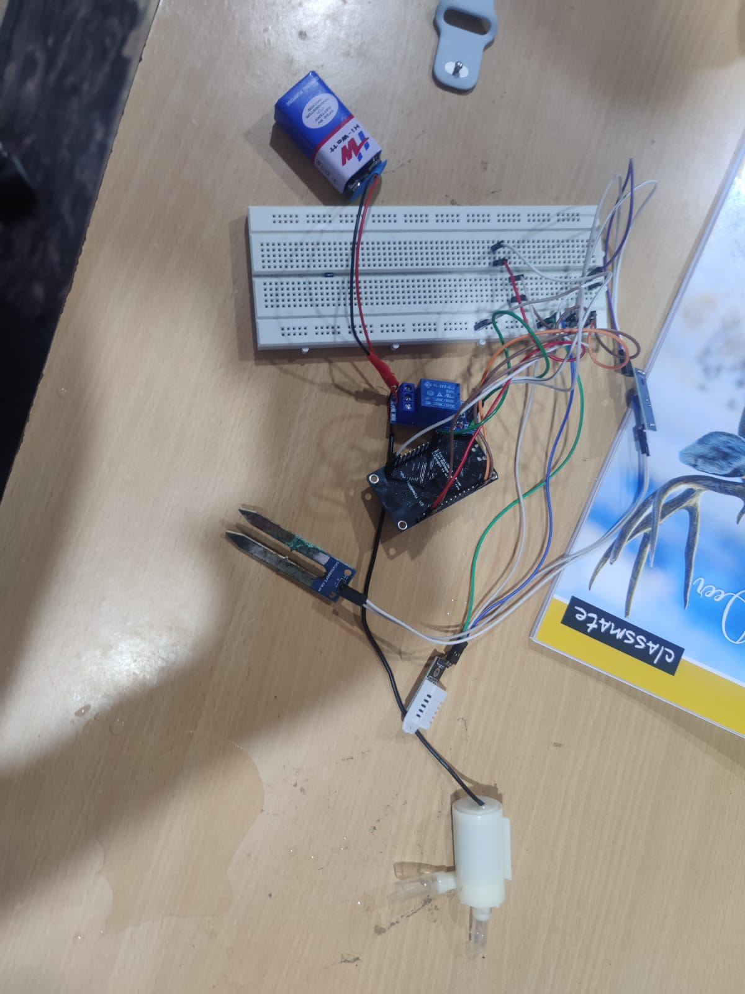

Figure 9:Image of automated hydroponic system

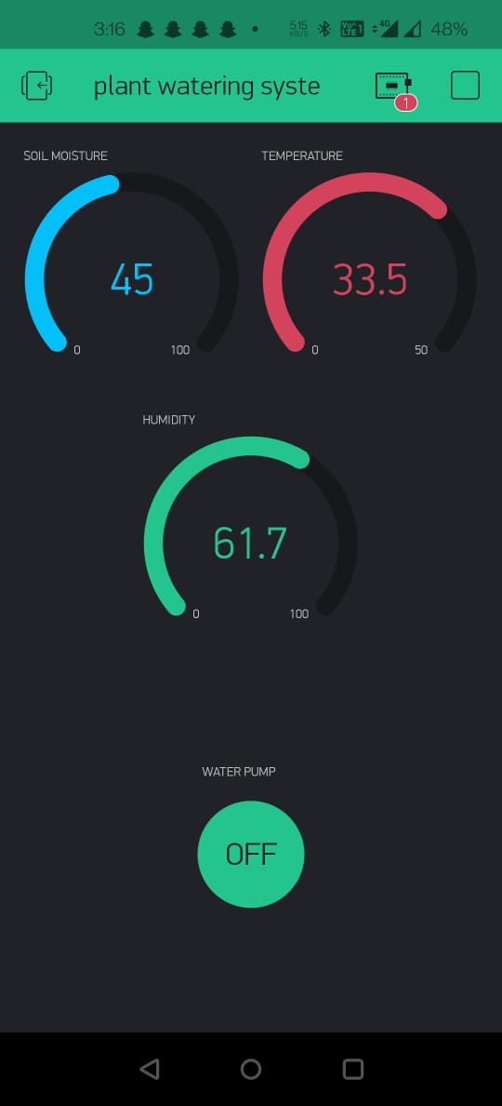

Figure 10: Graphical user interface for hydroponic system

# 6) Conclusion

**6.1) Limitations**

In conclusion, our whole work can be split into two main part. The first one being the growth of plants and creation of data set, in this we have grown the crops and taken the data with the help of sensors. In this aspect, there is minimal automation. The dataset is then created by taking the data and cleaning it to make sure that the anomalies are removed. With the help of this data set, we then move onto the second phase of the work. The second phase of this work is processing of the data set created and corelating the data to establish the best scenario for plant growth and good yield. With the help of Linear Regression, Support vector regression and Decision Tree Regression, we have established the parameters which are best corelated.

**6.2) Scope for future work**

For the work that can be done to further the progress done by us is to fully automate the system. With the correlation achieved by us, the parameters can be used to know the ambient conditions required when a certain parameter is fixed and cannot be altered in any way possible especially in the city environment in countries like India.

# Annexure – I (Sample codes)

Code for Hydroponic system

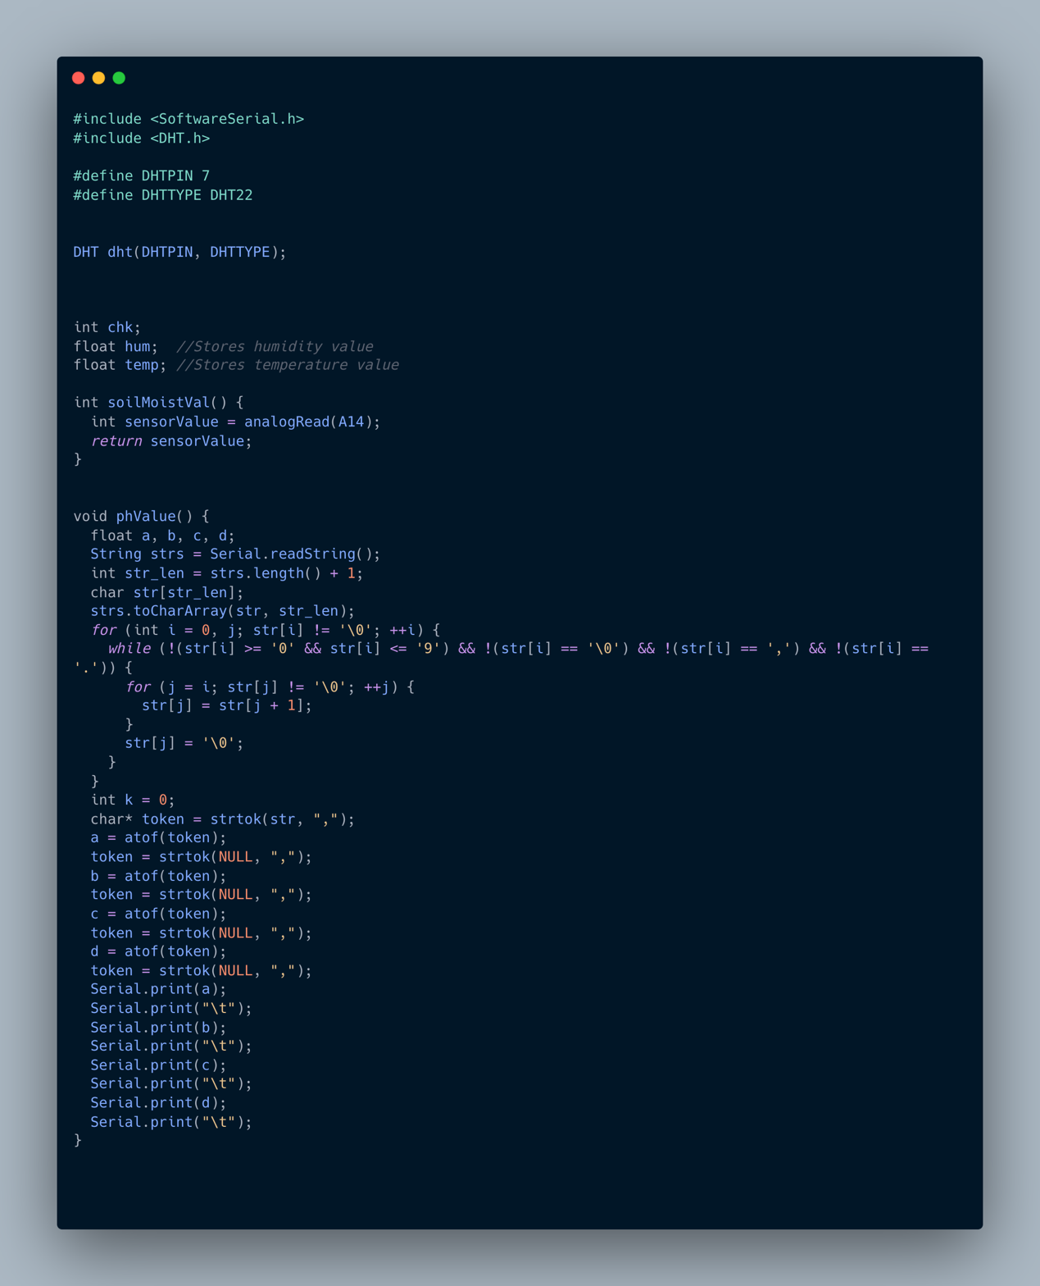

Figure 11: Hydroponic system code part-1

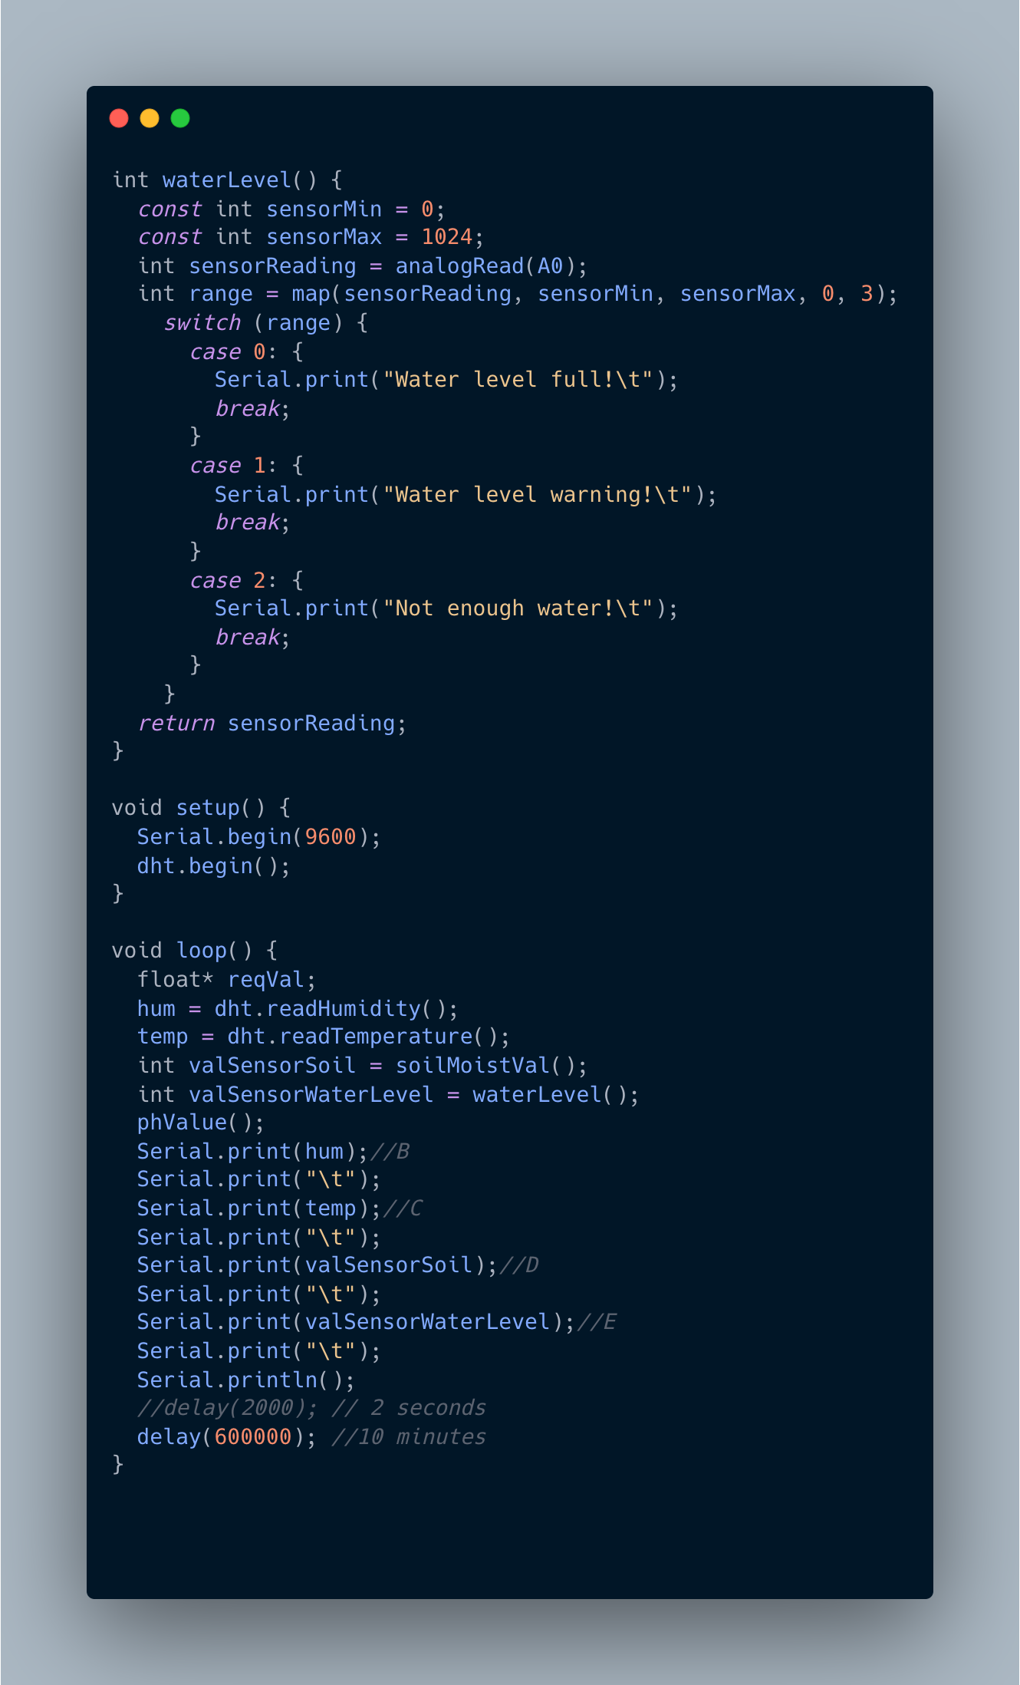

Figure 12:Hydroponic system code part 2

Code for Linear Variation system

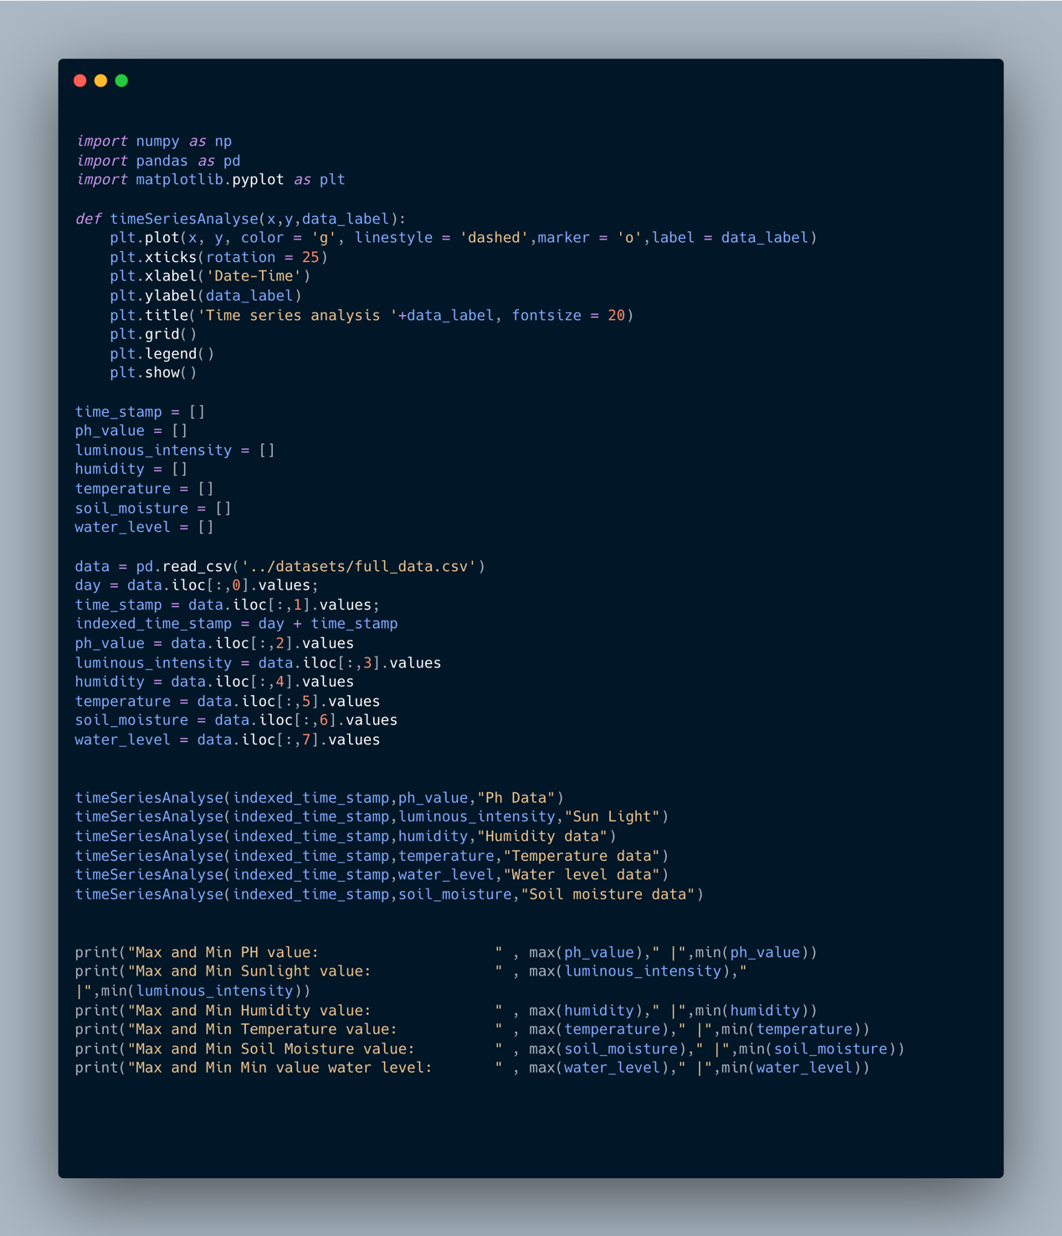

Figure 13:Code for data analysis

Code for machine learning analysis

Linear regression

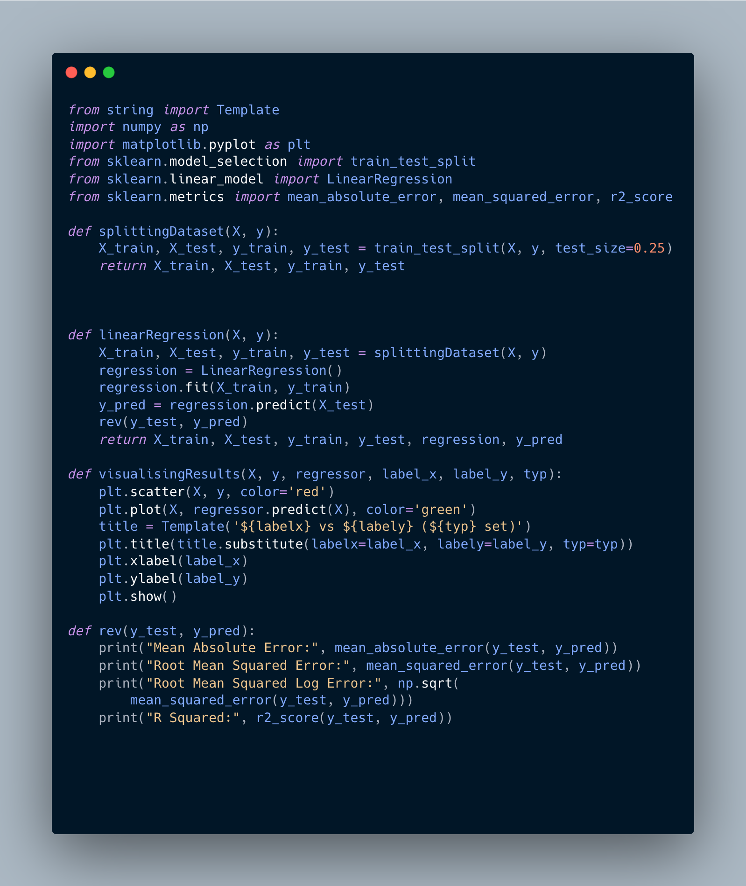

Figure 14:Code for linear regression analysis

SVR regression

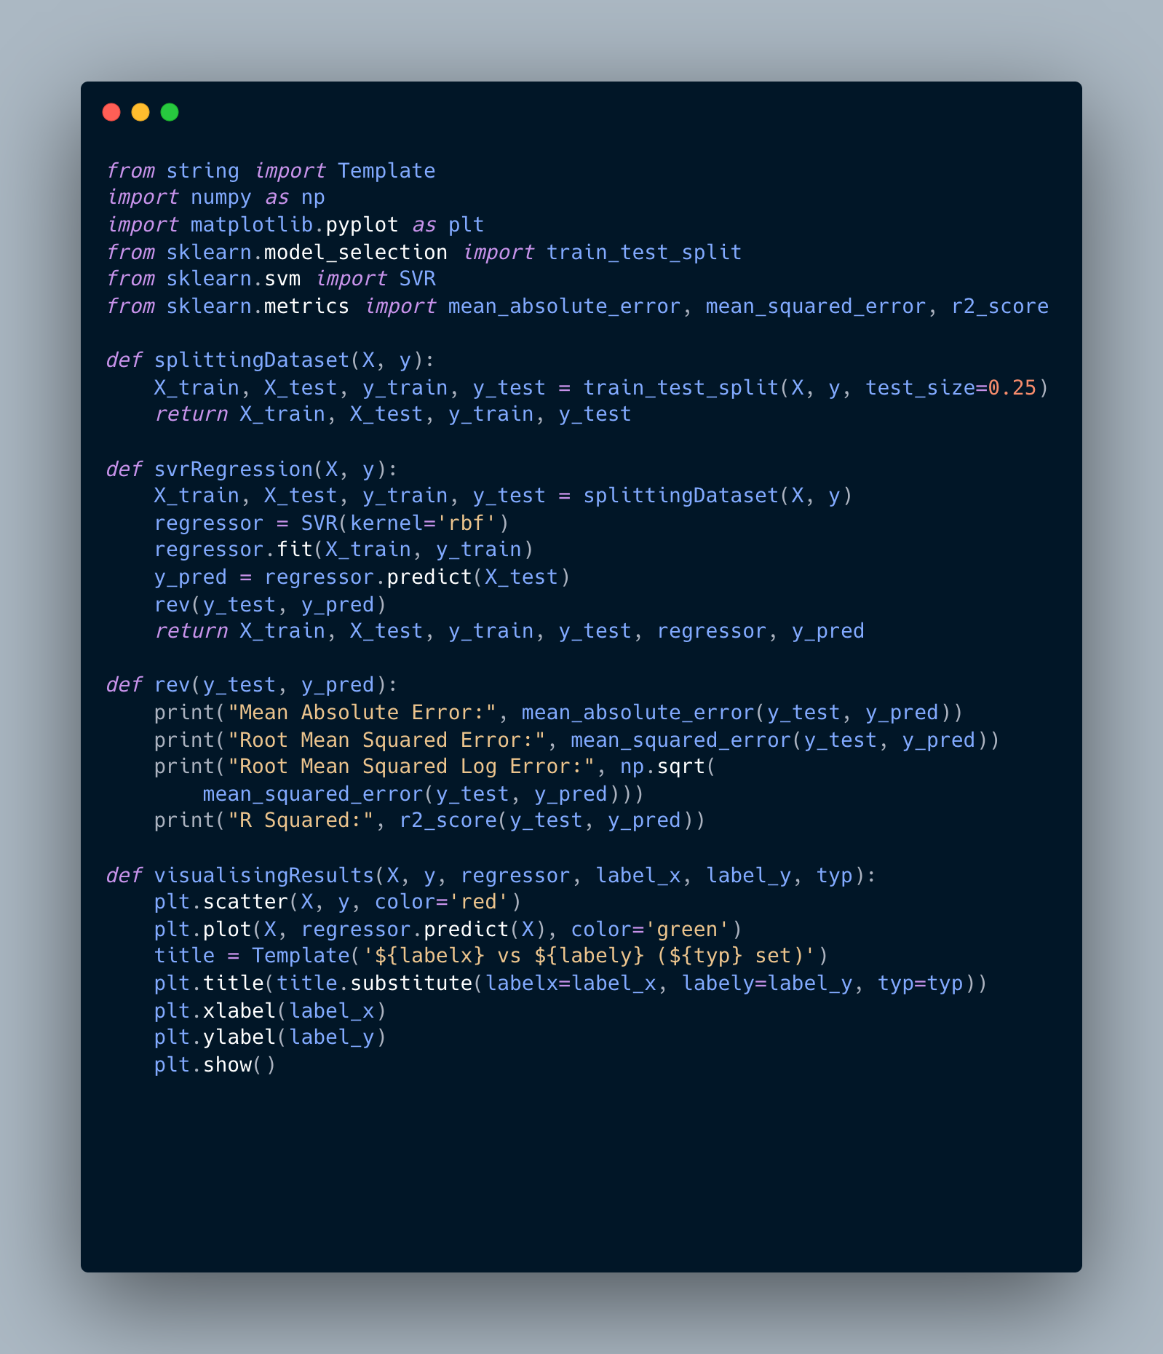

Decision tree regression

# 

Figure 15:Code for decision tree regression

# References

Weblinks:

1.https://www.thebetterindia.com/265317/uttar-pradesh-hydroponics-farm-home-grows-vegetables-fruits-earns-lakhs/

2.https://www.thebetterindia.com/265639/sandeep-kannan-vyavasai-bhoomi-tirupati-hydroponics-startup-farmer-success-story/

3.https://www.expresspharma.in/hydroponics-market-expected-to-grow-at-a-cagr-of-about-26-per-cent-by-2023/

4. https://krishijagran.com/agripedia/why-hydroponic-farms-are-trending-in-india/

Journal:

1. A. Nichani, S. Saha, T. Upadhyay, A. Ramya and M. Tolia, "Data Acquisition and Actuation for Aquaponics using IoT," 2018 3rd IEEE International Conference on Recent Trends in Electronics, Information & Communication Technology (RTEICT), 2018, pp. 46-51, doi: 10.1109/RTEICT42901.2018.9012260.

2. H. K. Srinidhi, H. S. Shreenidhi and G. S. Vishnu, "Smart Hydroponics system integrating with IoT and Machine learning algorithm," 2020 International Conference on Recent Trends on Electronics, Information, Communication & Technology (RTEICT), 2020, pp. 261-264, doi: 10.1109/RTEICT49044.2020.9315549.

3. P. Srivani, Y. Devi C. and S. H. Manjula, "A Controlled Environment Agriculture with Hydroponics: Variants, Parameters, Methodologies and Challenges for Smart Farming," 2019 Fifteenth International Conference on Information Processing (ICINPRO), 2019, pp. 1-8, doi: 10.1109/ICInPro47689.2019.9092043.

4. C. Joshitha, P. Kanakaraja, K. S. Kumar, P. Akanksha and G. Satish, "An eye on hydroponics: The IoT initiative," 2021 7th International Conference on Electrical Energy Systems (ICEES), 2021, pp. 553-557, doi: 10.1109/ICEES51510.2021.9383694.

5. S. Gertphol, P. Chulaka and T. Changmai, "Predictive models for Lettuce quality from Internet of Things-based hydroponic farm," 2018 22nd International Computer Science and Engineering Conference (ICSEC), 2018, pp. 1-5, doi: 10.1109/ICSEC.2018.8712676.

6. S. Jaisankar, P. Nalini and K. K. Rubigha, "A Study on IoT based Low-Cost Smart Kit for Coconut Farm Management," 2020 Fourth International Conference on I-SMAC (IoT in Social, Mobile, Analytics and Cloud) (I-SMAC), 2020, pp. 161-165, doi: 10.1109/I-SMAC49090.2020.9243486.

7. M. S. Farooq, S. Riaz, A. Abid, K. Abid and M. A. Naeem, "A Survey on the Role of IoT in Agriculture for the Implementation of Smart Farming," in IEEE Access, vol. 7, pp. 156237-156271, 2019, doi: 10.1109/ACCESS.2019.2949703.

8. N. Islam, B. Ray and F. Pasandideh, "IoT Based Smart Farming: Are the LPWAN Technologies Suitable for Remote Communication?," 2020 IEEE International Conference on Smart Internet of Things (SmartIoT), 2020, pp. 270-276, doi: 10.1109/SmartIoT49966.2020.00048.

9. S. Chaikhamwang, C. Janthajirakowit and S. Fongmanee, "IoT for Smart Farm: A Case Study of the Fertilizer Mixer Prototype," 2021 Joint International Conference on Digital Arts, Media and Technology with ECTI Northern Section Conference on Electrical, Electronics, Computer and Telecommunication Engineering, 2021, pp. 136-139, doi: 10.1109/ECTIDAMTNCON51128.2021.9425708.

10.  F. K. Syed, A. Paul, A. Kumar and J. Cherukuri, "Low-cost IoT+ML design for smart              farming with multiple applications," 2019 10th International Conference on Computing, Communication and Networking Technologies (ICCCNT), 2019, pp. 1-5, doi: 10.1109/ICCCNT45670.2019.8944791.